**АЛЕКСАХИНА А.А.,**

**ВАСИЛЬЕВА Е.А.,**

**ГОРБУНОВА Д.А.,**

**КРАВЕЦ А.Ю.**

**АУДИО-ВИДЕОХРЕСТОМАТИЯ**

**Пособие по английскому языку**

**VII -VIII СЕМЕСТРЫ**

**Student's book 2**

**(Книга для студента,**

**Том 2)**

**Москва 2022**

**ОГЛАВЛЕНИЕ**

**I GLOBALIZATON**

1. What is globalization? (rolin corporation) https://www.youtube.com/watch?v=xPD477FuqtY

2. IELTS Vocabulary. Useful words and phrases related to 'Globalisation' (Master IELTS) https://www.youtube.com/watch?v=rE6IesKI_t0

3. Globalization explained ([explainitychannel](https://www.youtube.com/channel/UCOo8aKrwtWmlLUEpatJ2nyg))https://www.youtube.com/watch?v=JJ0nFD19eT8

4. Who really wins from globalization (Global Economic Dynamics) https://www.youtube.com/watch?v=ovFjvcd6q1w

5. Michael Ignatieff on globalisation, Brexit and Trump (BBC Newsnight, 20 Jan 2017) https://www.youtube.com/watch?v=HZAtq_Nsrn8

6. Is Globalization Over? (Bloomberg Markets and Finance, 23 Dec 2019) https://www.youtube.com/watch?v=qmy3wsp_ODY

7. Davos 2019 - Globalization 4.0 ([SmithBusinessSchool](https://www.youtube.com/channel/UCljSqREYsADK1Tw4CAaFaPQ))https://www.youtube.com/watch?v=H5LxrgvJ2TI

8. Will covid kill globalization? ([The](https://www.youtube.com/channel/UCljSqREYsADK1Tw4CAaFaPQ) Economist)https://www.youtube.com/watch?v=KJhlo6DtJIk

**II EDUCATION**

1. British Education System Britain Explained ([Omoregie Oluwakemi](https://www.youtube.com/channel/UCTUjAl6wkngS2zIO-fG8iJg)) https://www.youtube.com/watch?v=ikgAs1au4a0

2. 8 Ways British and American Education Systems Are Very Different(Lost in the Pond) <https://youtu.be/jK0KeWwCYyY>

3. History of Ivy League Schools: Sports and Education (WatchMojo.com) <https://youtu.be/LUuTn3rVaQw>

4. Ivy League – WSJ (Wall Street Journal) <https://youtu.be/667pfuQ9lvc>

5. College admissions scam: How the privileged gamed the system (USA TODAY) <https://youtu.be/761_NYlT0yQ>

6. RUSSIAN and AMERICAN SCHOOLS: difference in education systems ([Skyteach: открытое сообщество учителей Skyeng](https://www.youtube.com/c/FriendlyEnglishSkyeng)) <https://youtu.be/obUmsZvJJO8>

7. Advantages and Disadvantages of Online Learning (Pat Belgrave) <https://youtu.be/XZsvsZ0Au4A>

**III RELIGION**

1. The five major world religions – John Bellaimey (TEDEd) https://www.youtube.com/watch?v=m6dCxo7t_aE

2. Why There is No Way Back for Religion in the West (TEDxUnivercityofEssex) https://www.youtube.com/watch?v=YtAR_OGzlcg

3. Is religion dying out in Britain? ([Humanists UK](https://www.youtube.com/channel/UCFHH0VMmsXEUzBzbClMkb0g)) https://www.youtube.com/watch?v=e7s0FOY2mo8

4. What Are the Most Atheist Countries? (NowThis World) https://www.youtube.com/watch?v=uEDObDdOPTA

5a. Islam - fastest growing religion (EWTN, 2017-09-15) https://www.youtube.com/watch?v=glAI5YMMw0Y

5b. The Future of World Religion (in 2050)) (TDC) https://www.youtube.com/watch?v=l3gpkP-Atpc

**GLOBALIZATION**

**Video 1***(What is globalization?) (rolin corporation)*

Before you watch.

1) What's globalization in your opinion?

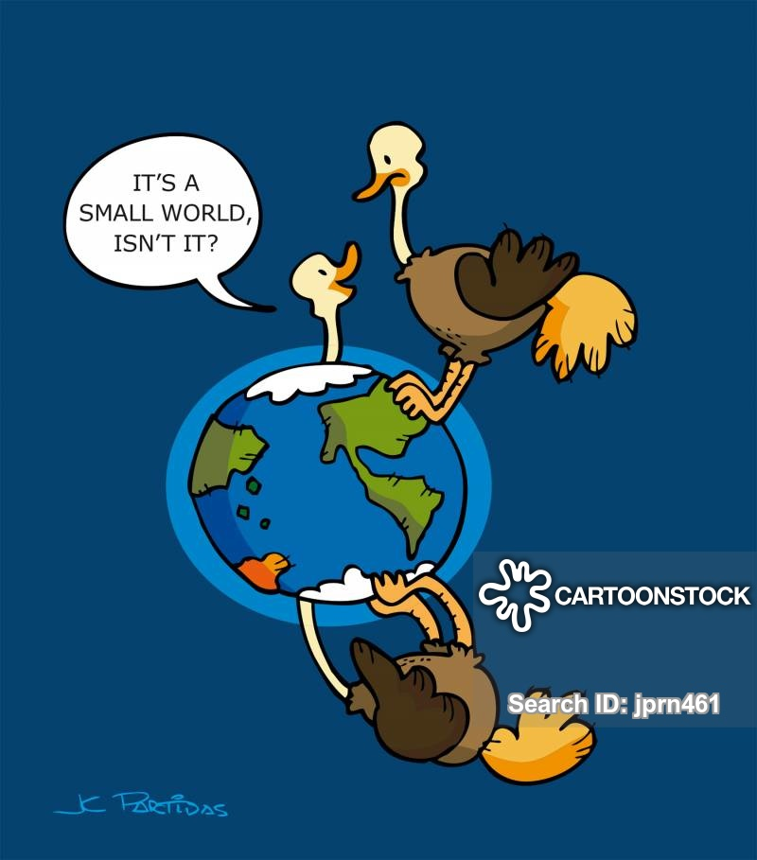

2) Look at the cartoon and say in what way it reflects the notion of globalization. 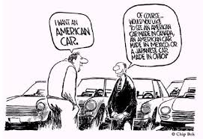

3) Do you happen to know what event Bretton Woods is associated with? Skim through the extract if needed.

The Bretton Woods Conference, formally known as the United Nations Monetary and Financial Conference, was the gathering of 730 delegates from all 44 [Allied nations](https://en.wikipedia.org/wiki/Allies_of_World_War_II) at the [Mount Washington Hotel](https://en.wikipedia.org/wiki/Mount_Washington_Hotel), situated in [Bretton Woods](https://en.wikipedia.org/wiki/Bretton_Woods,_New_Hampshire), [New Hampshire](https://en.wikipedia.org/wiki/New_Hampshire), [United States](https://en.wikipedia.org/wiki/United_States), to regulate the [international monetary and financial order](https://en.wikipedia.org/wiki/International_monetary_systems) after the conclusion of [World War II](https://en.wikipedia.org/wiki/World_War_II).

The conference was held from July 1 to 22, 1944.

Under the Bretton Woods System, gold was the basis for the U.S. dollar and other currencies were pegged to the U.S. dollar’s value. The Bretton Woods System effectively came to an end in the early 1970s when President Richard M. Nixon announced that the U.S. would no longer exchange gold for U.S. currency.

Watch the video and check yourself.

After you watch.

Answer the questions.

1) How did the spike in global trade in 1986 affect the world? Did it help to further globalization?

2) Does globalization amount to international trade only? How does it influence the world?

3) Does globalization affect world trade? Is it a positive or a negative influence?

4) What effect did global trade have on many world powers in history? Prove your point.

Read the articles and be ready to answer the questions.

1. What global economic system was born as a result of the Bretton Woods Conference? Why was it established? What are its advantages and disadvantages? Who was the main beneficiary in your opinion? Why did the system collapse and what consequences did it lead to?
2. What financial organizations established by the Bretton Woods agreements became operational in 1945?
3. Did the policies of global financial institutions together with the changes to the economic system help eliminate imbalances and make the system itself more stable?

**Bretton Woods Agreement and System**

By [JAMES CHEN](https://www.investopedia.com/contributors/101529/)

Apr 28, 2021

*The Bretton Woods Agreement and System Explained*

The Bretton Woods system of [monetary management](https://en.wikipedia.org/wiki/Monetary_system) established the rules for commercial and financial relations among the [United States](https://en.wikipedia.org/wiki/United_States), [Canada](https://en.wikipedia.org/wiki/Canada), [Western European](https://en.wikipedia.org/wiki/Western_Europe) countries, [Australia](https://en.wikipedia.org/wiki/Australia), and [Japan](https://en.wikipedia.org/wiki/Japan) after the 1944 Bretton Woods Agreement.

The primary designers of the Bretton Woods System were the famous British economist [John Maynard Keynes](https://www.investopedia.com/terms/j/john_maynard_keynes.asp) and American Chief International Economist of the U.S. Treasury Department Harry Dexter White. Keynes’ hope was to establish a powerful global central bank to be called the Clearing Union and issue a new international reserve currency called the bancor. White’s plan envisioned a more modest lending fund and a greater role for the U.S. dollar, rather than the creation of a new currency. In the end, the adopted plan took ideas from both, leaning more toward White’s plan.

Approximately 730 delegates representing 44 countries met in Bretton Woods in July 1944 with the principal goals of creating an efficient [foreign exchange](https://www.investopedia.com/terms/f/foreign-exchange.asp) system, preventing competitive devaluations of currencies, and promoting international economic growth.

The Bretton Woods Agreement also created two important organizations—[the International Monetary Fund (IMF) and the World Bank](https://www.investopedia.com/ask/answers/043015/what-difference-between-international-monetary-fund-and-world-bank.asp) which were formally introduced in December 1945.

[Soviet](https://en.wikipedia.org/wiki/Soviet_Union) representatives attended the conference but later declined to ratify the final agreements, charging that the institutions they had created were "branches of Wall Street".

It wasn't until 1958 that the Bretton Woods System became fully functional. Once implemented, its provisions called for the U.S. dollar to be pegged to the value of gold. Moreover, all other currencies in the system were then pegged to the U.S. dollar’s value. The exchange rate applied at the time set the price of gold at $35 an ounce.

*Benefits of Bretton Woods Currency Pegging*

As with the benefits of all currency pegging regimes, currency pegs are expected to provide currency stabilization for trade of goods and services as well as financing.

The Bretton Woods System, therefore, minimized international currency exchange rate volatility which helped international trade relations. More stability in foreign currency exchange was also a factor for the successful support of loans and grants internationally from the World Bank.

*The IMF and World Bank*

The purpose of the IMF was to monitor [exchange rates](https://www.investopedia.com/terms/e/exchangerate.asp) and identify nations that needed global monetary support. The World Bank, initially called the International Bank for Reconstruction and Development, was established to manage funds available for providing assistance to countries that had been physically and financially devastated by World War II.﻿ In the twenty-first century, the IMF has 189 member countries and still continues to support global monetary cooperation. Tandemly, the World Bank helps to promote these efforts through its loans and grants to governments.

*The Bretton Woods System’s Collapse*

In 1971, concerned that the [U.S. gold supply](https://www.investopedia.com/articles/forex-currencies/092316/how-us-dollar-became-worlds-reserve-currency.asp) was no longer adequate to cover the number of dollars in circulation, President Richard M. Nixon devalued the U.S. dollar relative to gold and declared a temporary suspension of the dollar’s convertibility into gold rendering it a [fiat currency](https://en.wikipedia.org/wiki/Fiat_currency).﻿ By 1973 the Bretton Woods System had collapsed. Countries were then free to choose any exchange arrangement for their currency, except pegging its value to the price of gold. They could, for example, link its value to another country's currency, or a basket of currencies, or simply let it float freely and allow market forces to determine its value relative to other countries' currencies.

Abridged and compiled from https://www.investopedia.com/terms/b/brettonwoodsagreement.asp and https://en.wikipedia.org/wiki/Bretton_Woods_system

**Advantages of the Bretton woods system**

Some of the benefits of the emergence of the Bretton woods system are as follows:

- Significant expansion in international trade and investment.

- Better macroeconomic performance.

- Inflation rates are on average low for every industrialized country except Japan.

- Real per capita income growth is higher.

But some leading economists today argue whether the stability of macroeconomic performance is a result of the success of Bretton Woods or just controversy.

*Criticism of the Bretton woods system*

In its history, the Bretton Woods system is not free from various criticisms. This system is highly dominated by US and British forces. Eric Hobsbawm in 1994 even considered that the US-centered world economy would have an impact on US dominance in the next quarter-century.

So the ability of Bretton Woods institutions is increasingly greater in regulating the world economy through and also for the strength of the US political economy.

It causes power imbalances between countries in multilateral cooperation that can cause harm to countries with weak power. The dominant party can have a great bargaining power in various aspects such as politics and economics.

This has implications often found in an international agreement that is not balanced or double standard in multilateral cooperation.

*Bretton Woods system didn’t reduce economic imbalance*

Some data show that liberal policies in multilateral cooperation have not been able to reduce the economic imbalance.

In 1947, the United States formed the GATT (General Agreement on Tariffs and Trade) which leads to economic liberalization by carrying out the mission of global capitalism which tends to be strongly imposed by certain countries both directly and through global economic-financial institutions.

It is ironic when developed countries manage to reap enormous economic benefits, but on the other hand, third world countries are still struggling with the problem of poverty.

Abridged from https://fxtrending.com/bretton-woods-system-summary

# Bretton Woods System and Its Breakdown | Economics

The principal changes introduced in the International monetary system included:

Firstly, the most significant development since 1978 in the international monetary relations has been the replacement of Special Drawing Rights (SDR’s) in place of gold as a reserve asset system. The official price of gold has been abolished and the restrictions on its sale in the open market have been removed. In fact, the IMF has been itself selling off gold reserves and putting the proceeds in the special funds.

The dominant reserve assets at present are the national currencies, about 75 percent of which are in the U.S. dollar. However, other major currencies have also gained importance. Since SDR is no longer related to gold, it has been linked with a basket of 16 major currencies.

Secondly, in order to relieve the problem of shortage of international liquidity, the IMF created several new credit facilities.

Thirdly, in the present international monetary system, the member countries are allowed either to float or peg their currencies. In the latter case, the exchange rate of one currency may be pegged to the currency of a particular country, the SDR or a basket of currencies. The exchange rate cannot be fixed in terms of gold. The exchange rate fixation or adjustments are subject to IMF supervision or guidelines. There are no limits on the margins within which these rates are pegged and there are no rules about how these should be altered.

In contrast to the structured arrangements of the gold standard and Bretton Woods System, the present system is more chaotic and reminiscent of the 1930’s.

Some serious shortcomings in the present monetary system are as follows:

(i) There is the existence of a variety of exchange rate regimes with very little effective supervision.

(ii) The reserve asset system depends on the portfolio decisions of central bankers.

(iii) In the present system, there are no accepted rules for sharing the adjustment to payments imbalances.

(iv) The emergence of floating exchange rates has greatly accentuated uncertainty in international trade. Consequently many traders, bankers and economists like to see the return to a more orderly system.

Abridged from https://www.economicsdiscussion.net/money/bretton-woods-system/bretton-woods-system-and-its-breakdown-economics/30535

**Video 2***(IELTS Vocabulary. Useful words and phrases related to 'Globalisation')* *(Master IELTS)*

Before you watch.

Look at the cartoon below. What notion related to globalization does it reflect? Is the world likely to turn into a global village? 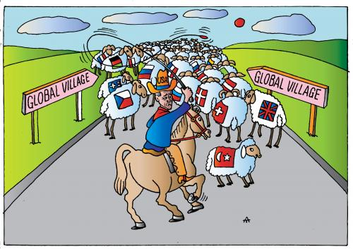

Watch the video and check yourself.

After you watch.

Answer the questions.

1) What are a developed and a developing country? Can you give any examples?

2) What is an emerging market economy? Can you name any?

3) What do developed countries often do to production in a globalised world? What consequences does it lead to?

4) What does a global village stand for?

5) How does globalization affect all people according to the video? Do you agree with this point of view?

6) What is consumerism? Is it an advantage or a disadvantage of globalization in your opinion?

7) What are cultural convergence and divergence? Is it important for nations to preserve cultural divergence? How does globalization affect it?

8) What disadvantages of globalization were mentioned in the video? What effect does globalization have on the environment and people's lifestyle?

Discussion point.

Work in a group. What other pros and cons of globalization can you come up with?Prove your point.

**Video 3** *(Globalization explained) ([explainitychannel](https://www.youtube.com/channel/UCOo8aKrwtWmlLUEpatJ2nyg))*

Before you watch.

1) Did advances in technology such as mobile phones, airplanes, telephones and the internet help spread globalization around the world? 

2) Is globalization good for local companies and producers? And what about customers?

Watch the video and check yourself.

After you watch.

Answer the questions.

1)What other kinds of exchange besides that of products and economic goods take place nowadays due to globalization?

2) How does outsourcing influence _ job markets in developed and developing countries? What are working conditions in developing countries like?

3) Is there any connection between globalization and climate change?

4) Do national environmental standards suffer?

Discussion point. Может, для единообразия Follow-up activity?

Work in groups. The video states globalization itself is neither good nor bad **-** it just depends on how people deal with all the new possibilities/opportunities(?) in the future.Do you share this opinion? Why / why not? Prepare a set of arguments for or against it and prove your point to the other group. The cartoon below might be of help.

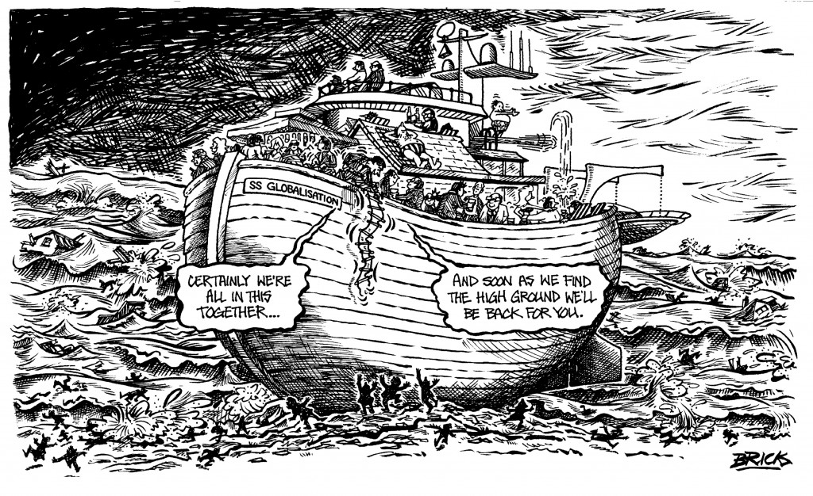

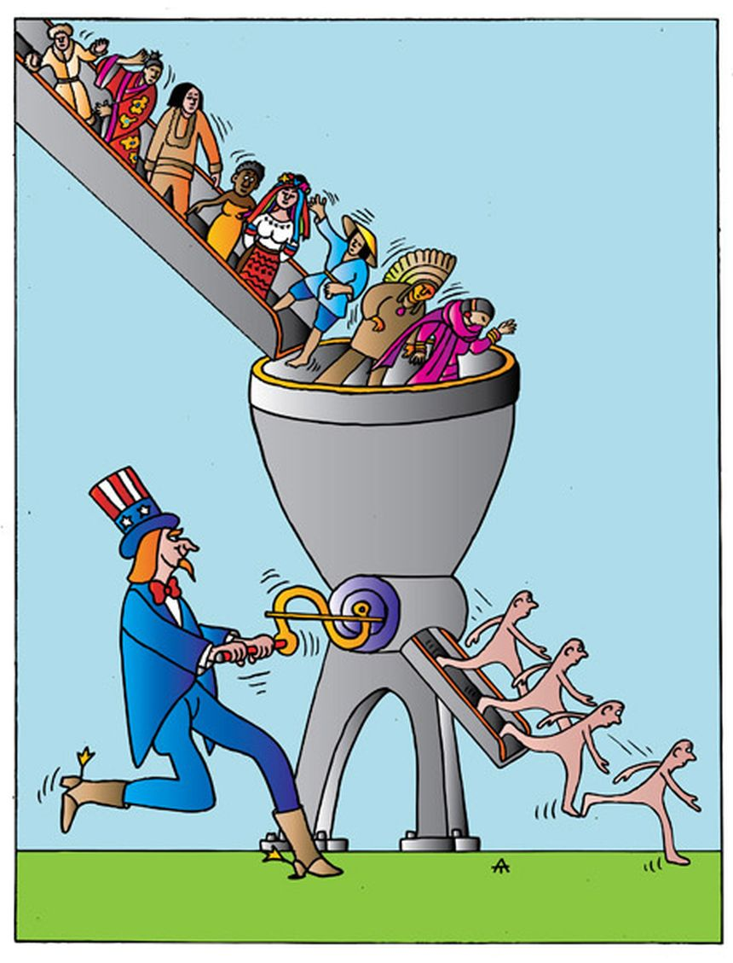**Video 4** *(Who really wins from globalization) (Global Economic Dynamics)*

Before you watch.

1) Read an extract from the video and say what your opinion on this topic is.

'This time we... try to add insight into the simmering debate about who really wins from globalization. The controversy around this topic is based on the belief that while interconnectedness may create winners, the process also creates losers. And that these losers come disproportionately from disadvantaged communities. The rhetoric is heated on both sides. For supporters, globalization is the key - 21st century growth motor. For opponents, globalization facilitates inequality and a race to the bottom in terms of standards. So which is it?'

2) Are there any clear-cut winners in your opinion? What about losers? Why / why not?

Watch the video and be ready to answer the questions.

1) Is the idea that globalization creates both winners and losers proven right by the study? How much did the real GDP of the countries studied grow on average?

2) Was there any difference between developed and developing countries in terms of gains? Are globalization opportunities evenly dispersed?

3) What does TTP stand for? Is it still valid?

*The* *Trans-Pacific Partnership (TPP*), also called the Trans-Pacific Partnership Agreement, was a proposed [trade agreement](https://en.wikipedia.org/wiki/Trade_agreement) between Australia, Brunei, Canada, Chile, Japan, Malaysia, Mexico, New Zealand, Peru, Singapore, Vietnam, and the United States signed on 4 February 2016. After the newly elected US president [Donald Trump](https://en.wikipedia.org/wiki/Donald_Trump) withdrew the US signature from TPP in January 2017, the agreement could not be ratified as required and did not enter into force. The remaining countries negotiated a new trade agreement called [*Comprehensive and Progressive Agreement for Trans-Pacific Partnership*](https://en.wikipedia.org/wiki/Comprehensive_and_Progressive_Agreement_for_Trans-Pacific_Partnership), which incorporates most of the provisions of the TPP and which entered into force on 30 December 2018.

4) In the long-run, what effect could regional trade pacts and interconnectedness have on developing countries?

Discussion point./ Follow-up activity(?)

Work in groups. Write a collective letter from the heads of _ developing countries urging the developed world to let emerging markets have even opportunities and enjoy same benefits from interconnectedness and globalization. What would you write to convince the other party? What counterarguments may they give?

**Video 5** *(Michael Ignatieff on globalisation, Brexit and Trump) (BBC Newsnight, 20 Jan 2017)*

Before you watch.

1) Do you know what these idioms stand for: a busted flush, to get a new lease of life, to take the rap for something? Look them up in a dictionary, if needed.

2) Can globalization be controlled? What do you think?

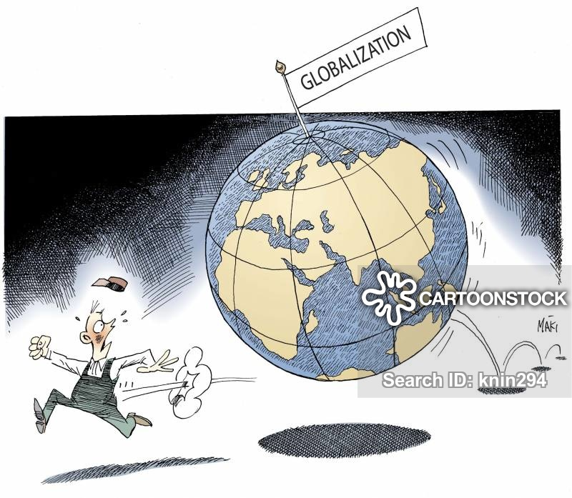

3) Read an extract from the video and say if it is happening that way in your opinion.

'We all want globalization when it works for us, when wages are rising, when we're working for globally competitive industries, when they're it's raising our incomes. We all want protection from globalization when suddenly we're working in declining industries, industries that are no longer competitive. We want it both ways at once and governments struggle to respond to these absolutely contradictory impulses from the public.'

After you watch.

Answer the questions.

1) What countries was globalization securely controlled by in the past?

2) Who is it powered by now?

3) What kind of reaction does a sense that they've lost control of globalization provoke in the USA and Britain?

4) Can globalization be stopped?

5) Which layers of society benefit from globalization and innovation?

6) What kind of _ solution do many governments which condemn globalization offer?

7) How did fear of globalization affect Europe's integrity?

8) Do ordinary people at the lower end of the wage scale get much protection from the government?

9) What happened in 2008? How did it affect the world? Skim through the extract, if needed.

The financial crisis of 2007–2008, also known as the global financial crisis (GFC), was a severe worldwide [financial crisis](https://en.wikipedia.org/wiki/Financial_crisis). Excessive risk-taking by banks combined with the bursting of the [United States housing bubble](https://en.wikipedia.org/wiki/United_States_housing_bubble) caused the values of [securities](https://en.wikipedia.org/wiki/Security_(finance)) tied to U.S. [real estate](https://en.wikipedia.org/wiki/Real_estate) to plummet, damaging financial institutions globally, culminating with the [bankruptcy of Lehman Brothers](https://en.wikipedia.org/wiki/Bankruptcy_of_Lehman_Brothers) on September 15, 2008, and an international [banking crisis](https://en.wikipedia.org/wiki/Banking_crisis). The crisis sparked the [Great Recession](https://en.wikipedia.org/wiki/Great_Recession), which, at the time, was the most severe global recession since the [Great Depression](https://en.wikipedia.org/wiki/Great_Depression). It was also followed by the [European debt crisis](https://en.wikipedia.org/wiki/European_debt_crisis), which began with a deficit in Greece in late 2009, and the [2008–2011 Icelandic financial crisis](https://en.wikipedia.org/wiki/2008%E2%80%932011_Icelandic_financial_crisis), which involved the [bank failure](https://en.wikipedia.org/wiki/Bank_failure) of all three of the major banks in [Iceland](https://en.wikipedia.org/wiki/Iceland) and, relative to the size of its economy, was the largest economic collapse suffered by any country in economic history.

Discussion point.

Is protectionism going to bring ordinary Americans their jobs back? Will it work out in other countries?

**Video 6** *(Is Globalization Over?) (Bloomberg Markets and Finance, 23 Dec 2019)*

Before you watch.

1) Do you know what this idiom stands for: to be in the driving seat? Look it up in a dictionary, if needed.

2) Do you think climate change can affect the future of globalization? Why / why not? The cartoon below might be of help.

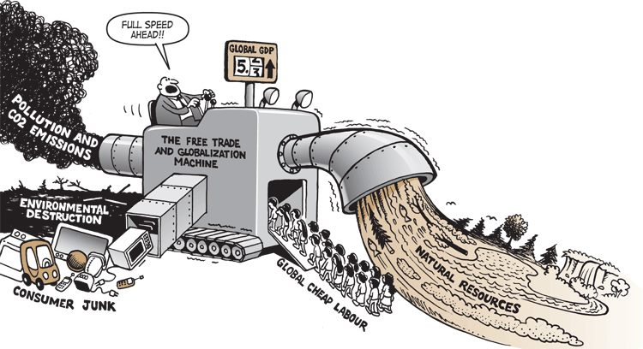

After you watch.

Answer the questions.

1) What ramifications of climate change for globalization can there(?) be? Can it pose a serious challenge to globalization?

2) Does the global financial crisis spell_ the end for globalization? How did the 2008 financial crisis influence globalization?

3) What countries are the primary architects of globalization? When did it all start?

4) How many models of globalization exist in the modern world? What's the difference between them?

5) Does globalization simultaneously benefit an economy as a whole and all the citizens? What consequences does it lead to?

Discussion point.

What other factors can have an impact on globalization? Make a list. Compare it with the other members of the group and give your reasoning. You can include the abovementioned challenges as well and develop the idea.

**Video 7** *(Davos 2019 - Globalization 4.0) ([SmithBusinessSchool](https://www.youtube.com/channel/UCljSqREYsADK1Tw4CAaFaPQ))*

Before you watch.

1) Do you know what these abbreviations stand for: R&D, AI? Look them up, if needed.

2) In your opinion has globalization evolved in any way throughout the history? The picture below may be of help. 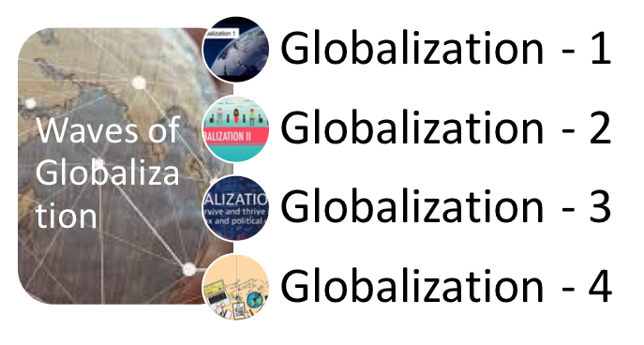

3) Read the article and be ready to answer the questions.

1. How drastic have the changes at different stages been? What tools are there to help futher globalization 4.0? What opportunities and challenges does it present?

**Globalization 4.0 or fourth industrial revolution**

Anuj Jindal

Apr 3, 2019

What is globalization:

Globalization is a phenomenon driven by technology and the movement of ideas, people, and goods. Globalization describes a process by which national and regional economies, societies, and cultures have become integrated through the global network of trade, communication, immigration, and transportation.

Waves of globalization

To understand what Globalization 4.0 means, it’s necessary to look back on the previous globalization waves 1.0, 2.0 and 3.0:

GLOBLIZATION 1.0:

Globalization 1.0 refers to the rapid growth in world trade, mainly during the nineteenth century or it can be called the pre-1914 period. It was driven by innovations in transport and communications, including the railways, steamships and the electric telegraph which further reduced the cost of global transport and enabled the separation of production and consumption across international borders.

GLOBLIZATION 2.0:

Globalization 2.0 or post 1945 era refers to the international industrialization after the Second World War. It is driven by greater international cooperation. The post-war period saw less protectionism and a rapid growth in world trade, at least in western economies.

GLOBLIZATION 3.0:

The third wave of globalization (globalization 3.0) is thought to have started around 1990 and was driven by advances in technology, including the spread of the internet. During this wave:

* It was easy for different stages of production to be based in various locations across the globe, leading to the emergence of modern supply chains.
* Firms were enabled to further cut the cost of producing products and delivering services by moving their operations to cheaper locations, known as offshoring.

 GLOBALIZATION 4.0

The current wave, Globalization 4.0, is a set to be driven by the Fourth Industrial Revolution, which is happening right now. In 2011, the term Industry 4.0 was introduced by the German government and Siemens. Industry 4.0 shifts manufacturing away from analog and mechanical technologies and toward all things digital.

TOOLS OF THE GLOBLIZATION 4.0

The development of advanced technologies has the potential to significantly impact global productivity. These technologies are-

* artificial intelligence
* big data
* nanotechnology
* the internet of things
* 3D printing
* autonomous vehicles

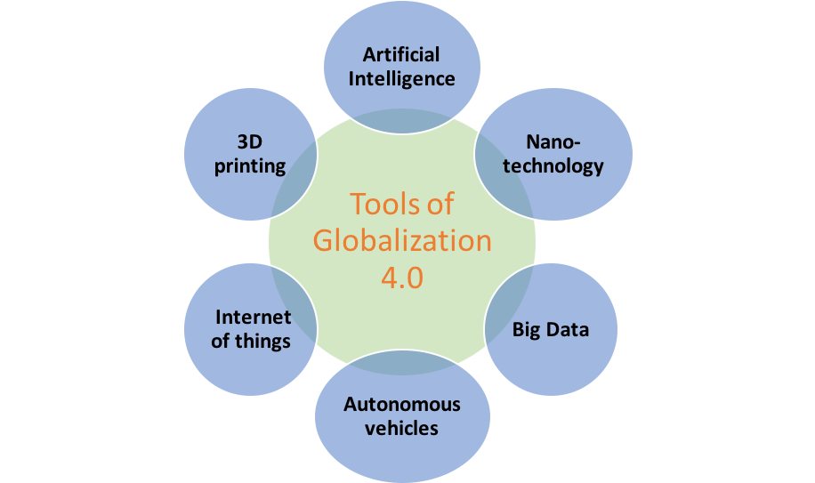

FEATURES OF THE GLOBLIZATION 4.0

(1) Digitally-enabled services:

Industry 4.0 is not only revolutionizing manufacturing processes but also increasing the ease of access to services. All previous waves were about the trade in goods. This one is about digitally-enabled services or we can say that previous waves were about blue-collar jobs this one is coming for white-collar workers. For ex. Online shopping, online transport facilities like Uber/Ola etc.

(2) Global public-private co-operation:

Public-private cooperation is about harnessing the private sector and open markets to drive economic growth for the public good.

(3) New model of education:

A new model of education complete with targeted programs for teaching workers new skills is required for managing the complete transformation in our system of health, transportation, communication, production, distribution and energy. This transformation needed new frameworks for national and multinational cooperation as well as a “new model of education”.

(4) Globally shared purpose:

Globalization 4.0 is leading to the new approach in the new economy of creating a community of shared interest and, ultimately, shared purpose which is universal but not isolated to a particular country, industry, or issue. It can be possible by developing policies that favor “and” over “or”. For ex. Environment’s problem has become global problem and global agencies collectively are trying to solve it by new technologies.

(5) Reducing inequalities and insecurities:

A desirable Globalization 4.0 will forge a new politics which reduce inequalities and insecurities and, rolling back rentier capitalism. An economic system in which the rewards for technological progress are shared more equitably. For ex. Mobile facility can be affordable by lower class of the economy.

Globalization 4.0 as a theme in the meet of “WEF” (World Economic Forum) 2019

The central theme of the 49th World Economic Forum’s Annual meeting, which was held in Davos, Switzerland from January 5 – January 25, 2019 was “Globalization 4.0: Shaping a New Architecture in the Age of the Fourth Industrial Revolution.”

Representatives at the Forum discussed the strategic ramifications of Globalization 4.0 and its future impact on global co-operation. Klaus Schwab, founder and Executive Chairman of the World Economic Forum, labels in the meet that the core of Globalization 4.0 is relying on digital connectivity and the related flow of ideas and services.

https://currentaffairs.anujjindal.in/globalization-4-0-or-fourth-industrial-revolution/

2. What does WEF stand for? What does it aim for? How will its initiatives affect the world?

The World Economic Forum suggests that a globalised world is best managed by a self-selected coalition of [multinational corporations](https://en.wikipedia.org/wiki/Multinational_corporation), [governments](https://en.wikipedia.org/wiki/Government) and [civil society organizations](https://en.wikipedia.org/wiki/Civil_society_organization) (CSOs), which it expresses through initiatives like the "[Great Reset](https://en.wikipedia.org/wiki/Great_Reset)" and the "Global Redesign". It sees periods of global instability – such as the [financial crisis of 2007–2008](https://en.wikipedia.org/wiki/Financial_crisis_of_2007%E2%80%932008) and the [COVID-19 pandemic](https://en.wikipedia.org/wiki/COVID-19_pandemic) – as windows of opportunity to intensify its programmatic efforts.

The Forum and its annual meeting in Davos have received criticism over the years. Challenges raised about the conference and the WEF include: the organization's corporate capture of global and democratic institutions, and institutional whitewashing initiatives; the public cost of security, the organization's tax-exempt status, unclear decision processes and membership criteria, a lack of financial transparency, and the [environmental footprint](https://en.wikipedia.org/wiki/Environmental_footprint) of its annual meetings.

After you watch.

Answer the questions.

1) What is globalization 1.0?

2) What does globalization 2.0 stand for according to the video?

3) What is globalization 3.0?

4) What does globalization 4.0 stand for? Does it spell the death of the previous waves of globalization?

5) According to the Economist globalization has turned to 'slowbalization'. Is such a situation really taking place? Prove your point.

6) What new forms does globalization 4.0 manifest itself in?

7) Does globalization 4.0 affect different states positively or negatively? What does that effect depend on?

Discussion point.

Organize a panel discussion whether globalization 4.0 will be a beneficial force. What about the other waves? Has globalization had a positive or negative effect on different states throughout the history? The article below may be of use.

**An economist explains the pros and cons of globalization**

Every industrial revolution has driven a wave of globalization. The first wave was driven by innovations such as the steam engine and the industrial weaving machine; the second by the assembly line, the car and the plane; and the third by the digital revolution.

As we enter the fourth wave of globalization, driven by the digital revolution, there is renewed debate over whether it is a beneficial force: powering economic growth, and allowing the spread of ideas to improve people’s lives; or whether it erodes communities, and widens the gap between the elites and the rest of the world.

Globalization results in increased trade and lower prices.

It heightens competition within domestic product, capital, and labour markets, as well as among countries adopting different trade and investment strategies.

But how do these impacts net out? What are the positive and negative effects of globalization? The below is an edited transcript of a conversation with Gita Gopinath, Chief Economist of the International Monetary Fund (IMF).

*Overall, what are the advantages of globalization?*

The advantages of globalization are actually much like the advantages of technological improvement. They have very similar effects: they raise output in countries, raise productivity, create more jobs, raise wages, and lower prices of products in the world economy.

*What might be the advantages of globalization that someone would feel in their day-to-day life?*

I think something that's not sufficiently appreciated about, for instance, international trade is that it reduces the prices of goods that they consume. So if you look at day-to-day things that you purchase, in terms of washing machines, or cars, or even clothing, because of international trade we've had a decline in prices of these goods, so they have become far more affordable for a lot of people in the world.

*How have the benefits played out in advanced economies versus poorer ones over the last three decades?*

Both advanced economies and developing economies have benefited overall in terms of having higher productivity, more job creation, and higher wages. As we've always known, and this is true again with technology, there are always some winners and losers. So there are communities and there are workers who lose out when there is more trade integration. That is what we're seeing right now in terms of discontent with international trade.

*Who have been the biggest losers?*

The biggest losers from international trade are always those whose skills have a cheaper competitor in a different market. So, in the case of the US, it's been those who work in the manufacturing sector because jobs in the manufacturing sector have been outsourced to countries where labour is far cheaper.

On the other hand, in developing countries, more capital-intensive goods get imported more cheaply from the outside. So if you're a manufacturer of a capital-intensive good in a developing country you tend to lose because of that competition.

This is how it is with international trade: production goes to wherever it is most efficient to produce. So, when people in any country are exposed to this kind of competition, some win and some lose.

Is it possible as an economist to come up with a verdict? Has this wave of globalized trade been a net positive or a net negative?

If you say, I'm going to look at it from a measure of overall effect on a country's income, on its purchasing power, on the prices that its people pay, overall I think the evidence that we have all points to it being a net positive.

Now, if you frame the question as, has international trade been good for the manufacturing worker in the US? Then the answer to that would be “not fully”; it's been very costly in terms of jobs and wages for them.

How optimistic are you that this next wave of globalization offers a better future?

I would make a couple of points. First, the previous waves of globalization have been quite successful in lifting a large number of people out of poverty and so we should appreciate that.

The second thing is that any form of globalization will generate winners and losers. So even if you have the perfect, most optimal international trade agreements, there will always be those who lose out because of competition, in the exact same way that people lose out whenever there's a new technology being developed.

And so if we want to make sure that the next wave of globalization is even more successful, it has to be complemented with good, sound domestic policies that help those who are getting left out.

*How optimistic are you that the trade war between the US and China will be swiftly resolved?*

It's absolutely essential that it be resolved, and it gets resolved in a way that's long lasting. The world economy has lived with the uncertainty about trade tensions for a while now and if there is any solution and there is a sense that the solution is only transitory and something can again get triggered in the future, I think that's very costly.

I'd say I'm mildly optimistic because I think leaders in the world are recognizing that these trade tensions are having a negative effect on their economies and so it would make sense to sit down and resolve it.

Written by

[Ceri Parker](https://www.weforum.org/agenda/authors/ceri-parker), Commissioning Editor, Agenda, World Economic Forum

*The views expressed in this article are those of the author alone and not the World Economic Forum.*

https://www.weforum.org/agenda/2019/04/an-economist-explains-the-pros-and-cons-of-globalization-b2f0f4ae76/?platform=hootsuite

**Video 8** *(Will covid kill globalization?) (*[*The*](https://www.youtube.com/channel/UCljSqREYsADK1Tw4CAaFaPQ) *Economist)*

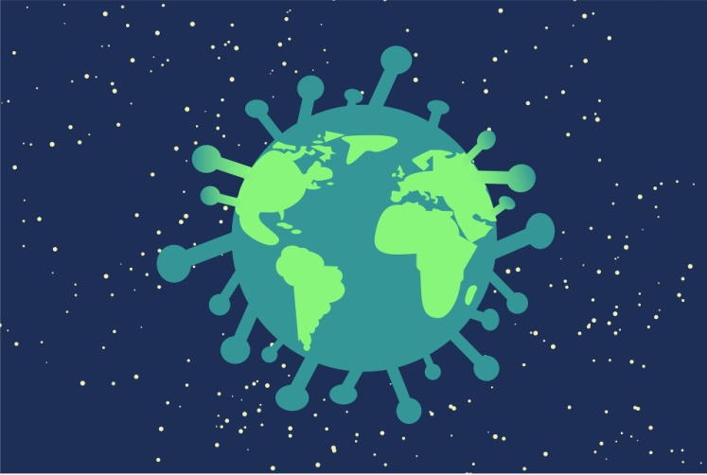Before you watch.

1) Does global instability – be it a crisis or a pandemic – have an profound effect on globalization?

2) What spheres will be affected and why?

3) What way in your opinion will globalization go after such an emergency?

After you watch.

Answer the questions.

1) Did covid-19 inflict serious damage on globalization?

2) What industries were hit hard? Why?

3) What were the ramifications for the world and individual countries?

4) When were the roots of today's heavily globalized world put down?

5) What happened in 1990s? What consequences did it lead to?

6) Did globalization face any other challenges before the pandemic?

7) What was free trade challenged by? What measures were taken by governments and what effect did they have on world trade?

8) Why did a trade war between the USA and China start?

9) What was the third blow to globalization? What did it result in?

10) What does the future for globalization look like?

11) How do multinational corporations react to the challenge? Is there any way out?

12) What other challenges does globalization confront?

13) What consequences can it lead to? Who will the winners and losers be and why?

Discussion point.

Read the article bellow and say whether you agree with the assessment and prognosis given. Were they accurate? Will globalization be able to withstand further challenges that arise? Give arguments to support your point of view.

***Has covid-19 killed globalisation?***

The flow of people, trade and capital will be slowed

May 14th 2020 The Economist

Even before the pandemic, globalisation was in trouble. The open system of trade that had dominated the world economy for decades had been damaged by the financial crash and the Sino-American trade war. Now it is reeling from its third body-blow in a dozen years as lockdowns have sealed borders and disrupted commerce. The number of passengers at Heathrow has dropped by 97% year-on-year; Mexican car exports fell by 90% in April; 21% of transpacific container-sailings in May have been cancelled. As economies reopen, activity will recover, but don’t expect a quick return to a carefree world of unfettered movement and free trade. The pandemic will politicise travel and migration and entrench a bias towards self-reliance. This inward-looking lurch will enfeeble the recovery, leave the economy vulnerable and spread geopolitical instability.

The world has had several epochs of integration, but the trading system that emerged in the 1990s went further than ever before. China became the world’s factory and borders opened to people, goods, capital and information. After Lehman Brothers collapsed in 2008 most banks and some multinational firms pulled back. Trade and foreign investment stagnated relative to GDP, a process this newspaper later called slowbalisation. Then came President Donald Trump’s trade wars, which mixed worries about blue-collar jobs and China’s autocratic capitalism with a broader agenda of chauvinism and contempt for alliances. At the moment when the virus first started to spread in Wuhan last year, America’s tariff rate on imports was back to its highest level since 1993 and both America and China had begun to decouple their technology industries.

Since January a new wave of disruption has spread westward from Asia. Factory, shop and office closures have caused demand to tumble and prevented suppliers from reaching customers. The damage is not universal. Food is still getting through, Apple insists it can still make iPhones and China’s exports have held up so far, buoyed by sales of medical gear. But the overall effect is savage. World goods trade may shrink by 10-30% this year. In the first ten days of May exports from South Korea, a trade powerhouse, fell by 46% year-on-year, probably the worst decline since records began in 1967.

The underlying anarchy of global governance is being exposed. France and Britain have squabbled over quarantine rules, China is threatening Australia with punitive tariffs for demanding an investigation into the virus’s origins and the White House remains on the warpath about trade. Despite some instances of co-operation during the pandemic, such as the Federal Reserve’s loans to other central banks, America has been reluctant to act as the world’s leader. Chaos and division at home have damaged its prestige. China’s secrecy and bullying have confirmed that it is unwilling—and unfit—to pick up the mantle. Around the world, public opinion is shifting away from globalisation. People have been disturbed to find that their health depends on a brawl to import protective equipment and on the migrant workers who work in care homes and harvest crops.

This is just the start. Although the flow of information is largely free outside China, the movement of people, goods and capital is not. Consider people first. The Trump administration is proposing to curtail immigration further, arguing that jobs should go to Americans instead. Other countries are likely to follow. Travel is restricted, limiting the scope to find work, inspect plants and drum up orders. Some 90% of people live in countries with largely closed borders. Many governments will open up only to countries with similar health protocols: one such “travel bubble” is mooted to include Australia and New Zealand and, perhaps, Taiwan and Singapore. The industry is signalling that the disruption to travel will be lasting. Airbus has cut production by a third and Emirates, a symbol of globalisation, expects no recovery until 2022.

Trade will suffer as countries abandon the idea that firms and goods are treated equally regardless of where they come from. Governments and central banks are asking taxpayers to underwrite national firms through their stimulus packages, creating a huge and ongoing incentive to favour them. And the push to bring supply chains back home in the name of resilience is accelerating. On May 12th Narendra Modi, India’s prime minister, told the nation that a new era of economic self-reliance has begun. Japan’s covid-19 stimulus includes subsidies for firms that repatriate factories; European Union officials talk of “strategic autonomy” and are creating a fund to buy stakes in firms. America is urging Intel to build plants at home. Digital trade is thriving but its scale is still modest. The sales abroad of Amazon, Apple, Facebook and Microsoft are equivalent to just 1.3% of world exports.

The flow of capital is also suffering, as long-term investment sinks. Chinese venture-capital investment in America dropped to $400m in the first quarter of this year, 60% below its level two years ago. Multinational firms may cut their cross-border investment by a third this year. America has just instructed its main federal pension fund to stop buying Chinese shares, and so far this year countries representing 59% of world GDP have tightened their rules on foreign investment. As governments try to pay down their new debts by taxing firms and investors, some countries may be tempted to further restrict the flow of capital across borders.

*It’s lonely out there*

Don’t be fooled that a trading system with an unstable web of national controls will be more humane or safer. Poorer countries will find it harder to catch up and, in the rich world, life will be more expensive and less free. The way to make supply chains more resilient is not to domesticate them, which concentrates risk and forfeits economies of scale, but to diversify them. Moreover, a fractured world will make solving global problems harder, including finding a vaccine and securing an economic recovery.

Tragically, this logic is no longer fashionable. Those three body-blows have so wounded the open system of trade that the powerful arguments in its favour are being neglected. Wave goodbye to the greatest era of globalisation—and worry about what is going to take its place.

*This article appeared in the Leaders section of the print edition under the headline "Goodbye globalisation"*

**EDUCATION**

**Video 1** *(British Education System Britain Explained) (*[*Omoregie Oluwakemi*](https://www.youtube.com/channel/UCTUjAl6wkngS2zIO-fG8iJg)*)* *(*https://www.youtube.com/watch?v=ikgAs1au4a0)

Before you watch.

1. What do you know about the education system in the UK? (What are the key stages of education; what types of schools can you recall, what are the variants of further or higher education?)
2. In what way does the education system of the UK differ from the education system of Russia? (What are the pluses and minuses of both systems?)
3. Can you enumerate best-known universities of the UK? (What are they famous for? What are the advantages of studying there?
4. Look at the cartoon below and say what problems in the education system of the UK the artist wants to reflect.

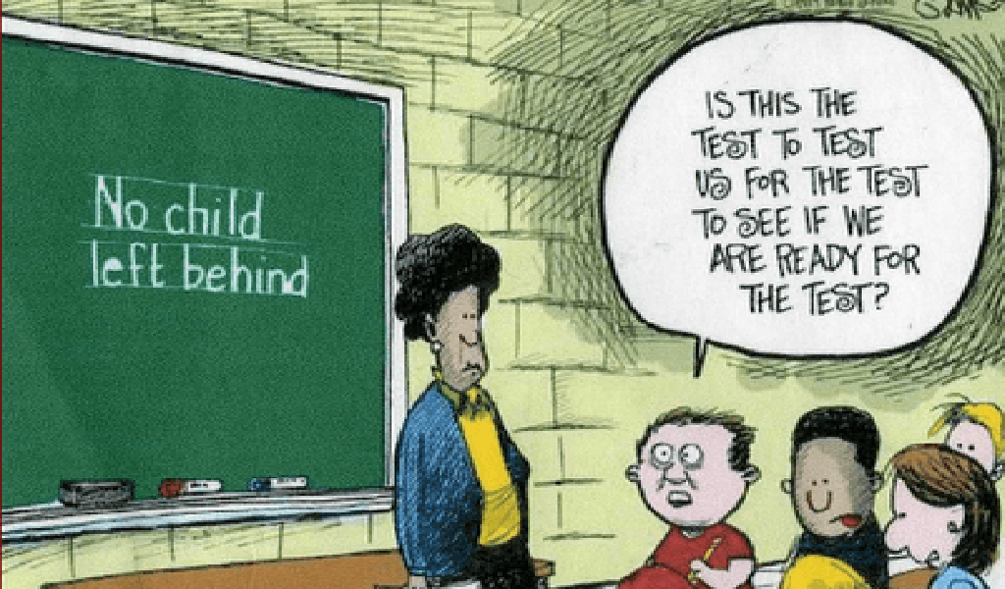



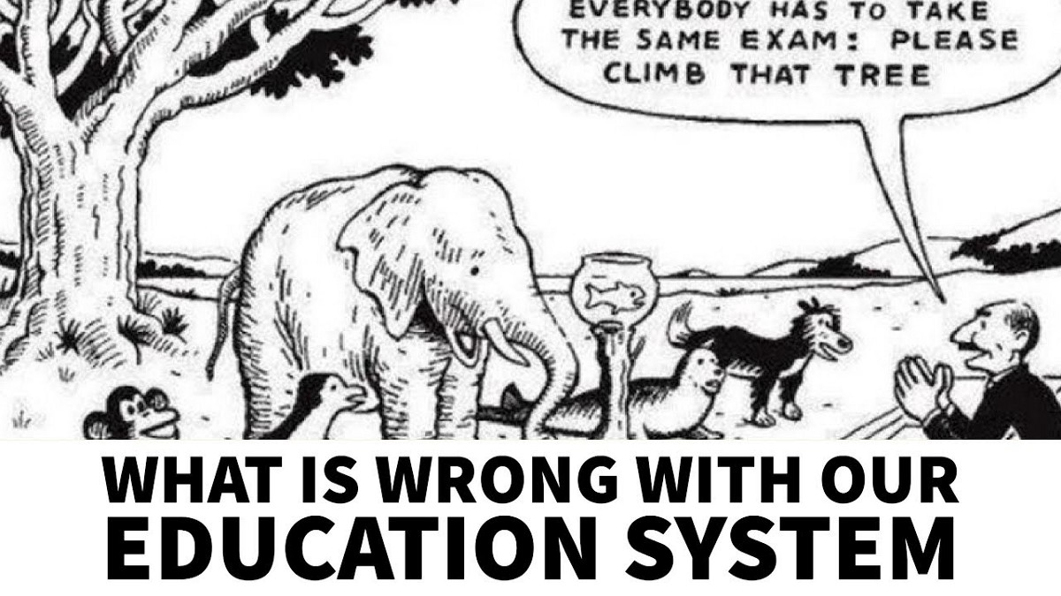 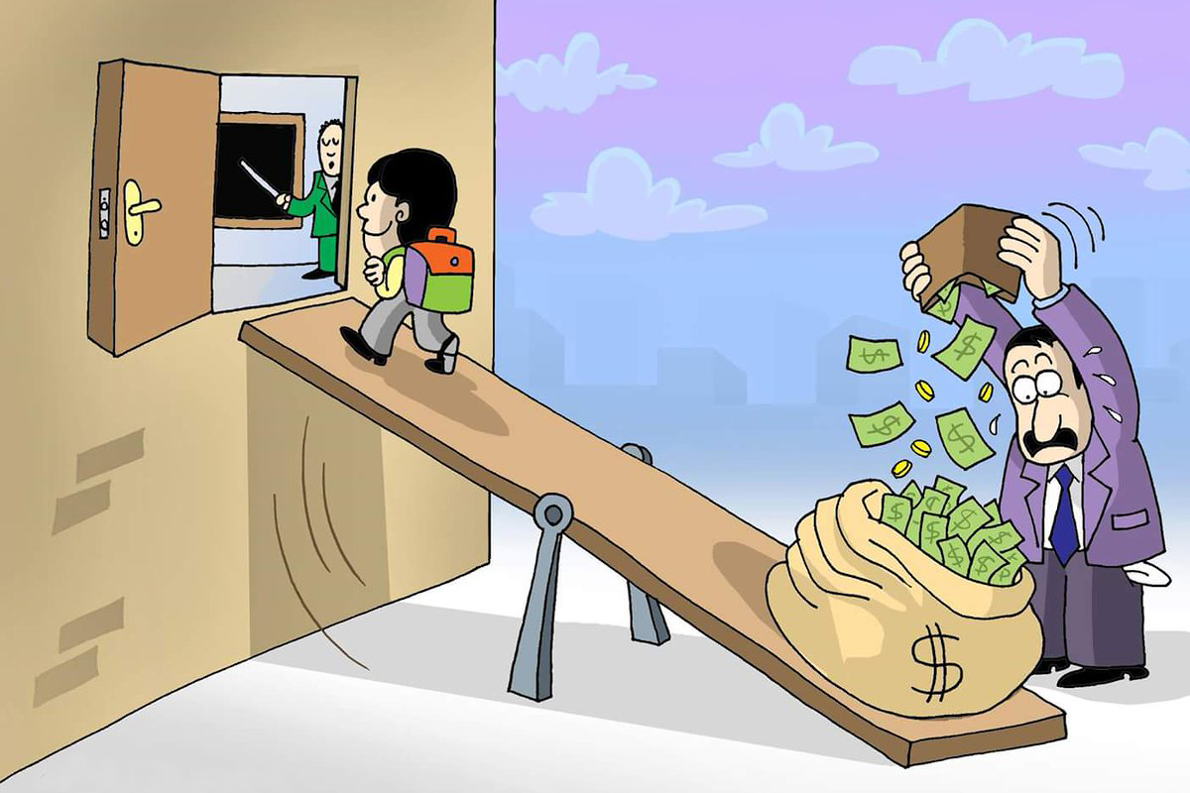 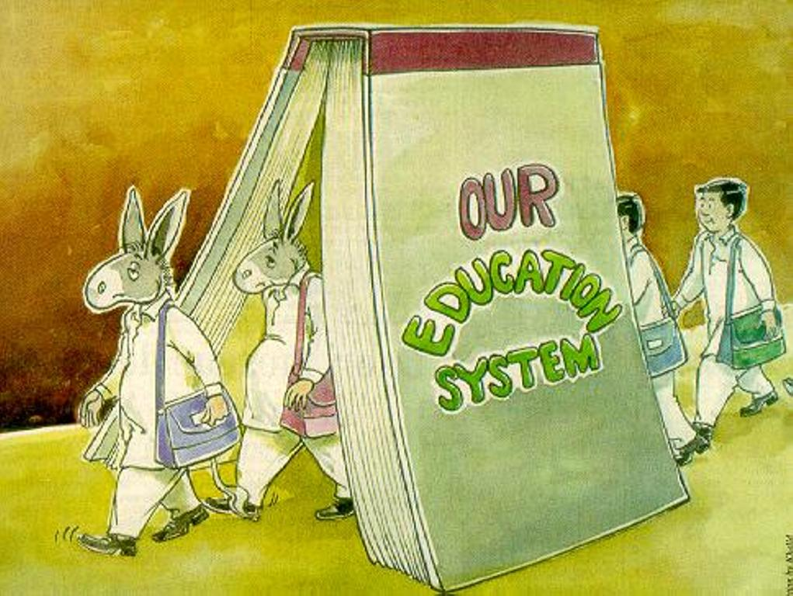

After you watch.

Answer the questions.

1. What does the term “compulsory education” mean? What is the age period for compulsory education?
2. What does the term “national curriculum” mean? When was it introduced for the first time?
3. What are 2 main types of schools in Britain? What have you learnt about public schools?
4. What is the name of the first stage of education in the UK?
5. What kinds of secondary schools are there in the UK?
6. What is GCSE(s)?
7. What choice do you have to make at the age of 16?
8. What is the full for IB?
9. What is meant by a BTech or NVQ?
10. That have you learnt about faith schools in Britain?
11. What are the requirements to enter university?
12. How long does it take to get a bachelor’s degree?
13. What is the grading system at the finals?
14. What is Freshers’ Week?
15. What red-brick universities can you name?
16. What a post graduate degree can a person do?

Watch the video for the 2nd time to get ready to sum up the key stages and notions of the education system in the UK (make up a scheme to use it as a plan).

Scan the article and say what kind of problems the UK education system is facing now.

**Anxious middle-classes look to private schools after coronavirus disruption**

*Exodus will create an even larger divide between affluent and disadvantaged pupils*

Increasing numbers of middle-class parents are planning to desert state schools this coming September, over anxieties their children have “fallen behind” private school pupils during lockdown and growing fears about the threat of further disruption to state education next year.

The Independent [Schools](https://www.theguardian.com/education/schools) Association told the Observer that it has noticed an upsurge in the number of what it describes as “high-aspirational, worried” parents of state school pupils looking for private school places in September, while the Independent Association of Prep Schools said demand had increased considerably during recent weeks.

More than a dozen headteachers at private schools contacted by the Observer said they had seen an extraordinary surge in inquiries from “unhappy” parents of state school pupils, with several schools across the country reporting a 20-30% increase in demand for places.

In April, just 3% of state-funded primary and 6% of state-funded secondary schools managed to provide “live” online lessons for students with their teachers, compared to 59% of private primary and 72% of private secondary schools, according to a survey by [Teacher Tapp](https://teachertapp.co.uk/live-lessons-relaxing-in-the-pandemic-and-are-teachers-going-abroad-this-summer/).

“Many affluent middle-class families sending their children to state schools have become aware and often concerned about the digital divide between state and private sector,” said Diane Reay, emeritus professor of education at Cambridge University “Fleeing to the private sector is an easier option than campaigning for state schools to be properly resourced and equipped, which is what should be happening. The state sector has always been the poor relation in education – around 25% of education spending goes on the 7% who are privately educated – but more middle-class flight will impoverish the sector more.”

Reay warned that the social class gap between private and state school pupils will widen as a result of the pandemic, and a compounding parallel gap in achievement will also open up. “It is this that middle-class parents are becoming alarmed about. If the 7% are about to accelerate and amplify their educational advantage, then middle-class parents who have always felt ambivalent about the state sector will want to join them. That’s going to entrench class inequalities in education, as the privately educated move even further away in terms of their privilege and advantage.”

Andrew McCleave, headteacher of Ballard School, an independent day school in the New Forest, said parents had been impressed by the school’s decision to provide a full timetable of lessons during lockdown, with the majority delivered by teachers online. As soon as the school closed, “we knew that we would be able to deliver our education that way. Our pupils have greater access to technology [than state school pupils]: if we want to do a Zoom lesson, we can pretty much guarantee that every one of our pupils will be able to access it, while state schools won’t be able to.”

He pointed out that private schools also have much smaller classes than state schools, and added that, compared to state schools he knew of, more of his teachers were actually available to teach online. “If staff are in school supervising key workers’ children, they can’t be delivering online lessons to children who aren’t in school. We had a few doctors among our parents, but we didn’t have a lot of key workers’ children in. That meant our staff could deliver live lessons to everyone.”

He agreed with Reay that inequalities are being cemented and an academic gap is opening up between private and state school pupils. “There’s no way that the children who are getting online lessons from independent schools are not going to be at an advantage … Because they’ve been taught and others haven’t.”

Jules White, headteacher and leader of the Worth Less campaign for more state school funding, said the idea that state schools had somehow failed parents and pupils was “very odd”. “Throughout the crisis, state schools were instrumental in protecting children of low-paid key workers, students from disadvantaged backgrounds and those with special educational needs. On much, much less funding than private schools, families of vulnerable children – and many others – were supported.”

The Department for Education said the government had invested more than £100m supporting remote education, and launched Oak National Academy to provide online lessons to pupils during lockdown. A spokesperson said: “Schools and teachers have gone to great lengths over recent months to support and educate children at home and in the classroom.”

He added: “Our £1bn Covid catch-up fund will help all children to make up for the impact lost time in school has had on their education.”

https://www.theguardian.com/education/2020/jul/26/anxious-middle-classes-look-to-private-schools-after-coronavirus-disruption

**Video 2** *(8 Ways British and American Education Systems Are Very Different)* *(Lost in the Pond)* (<https://youtu.be/jK0KeWwCYyY>) (2:26 –12:48)

Before you watch.

1. Are British and American Education Systems similar? Have you heard about any differences? (uniform, types of schools, price, grades, exams, terminology). Which one is better to your mind?
2. Study the tables below and sum up the main differences in the education systems in the UK and the US.

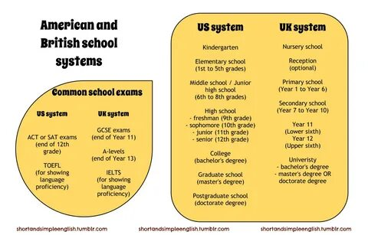

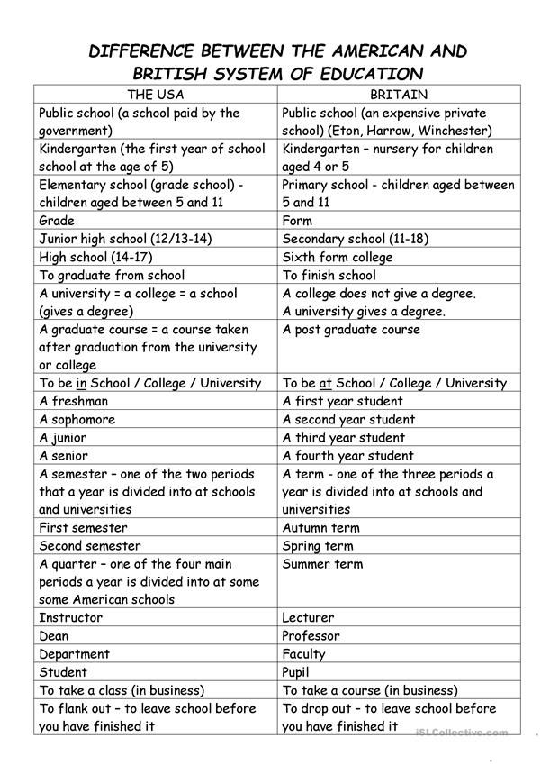

After you watch.

1. In what way does the school uniform differ in the UK from the uniform in the USA?
2. What have you learnt about differences in numbering systems to denote a child’s educational development?
3. What is the difference in terminology concerning the pre-school education in both countries?
4. Elementary school and primary school: what are the main differences?
5. In what way does middle school in the USA differ fron the secondary school in the UK?
6. What is the British equivalent to the US high school? (give the names for the exams in both counties)
7. Clarify the main differences in higher education in the UK and the USA.
8. Make up a list of different words denoting the same ideas in American and British English.

Now scan the article dedicated to the advantages and disadvantages of getting higher education in the UK and in the USA. Be ready to sum up the information using the table after the article. Make your own conclusion which system is more advanced and preferable.

**A**ccording to the world university rankings compiled by the Times Higher Education, more than half of the world’s top 200 universities are located in either the US or the UK. Both countries share a rich tradition of quality higher education, excellent research facilities, and a culture that promotes intellectualism as well as academic freedom. However, while both certainly provide an excellent environment for learning, there are many differences between the two countries regarding the structure of the university as well as student life. In this article, we will explore the primary differences between the American and British systems of education.

**Length of Time**

Perhaps the most important difference between the education system [in the US](https://www.internationalstudent.com/study_usa/choosing-the-usa/), and [the UK](https://www.internationalstudent.com/study_uk/education_system/), is the amount of time it takes to finish your degree (except in Scotland, where a bachelor’s degree also lasts four years). In general, degree programs in the US take about one year longer than programs in the UK, although this varies depending upon whether you receive a Master’s degree prior to a PhD. In both systems, you can go directly to a PhD program out of your undergraduate program, but in the UK it is more common to complete a Master’s degree program before moving on to a PhD. Courses of study are shorter in the UK because the course programs are generally much more focused than in the US.

**Academic Term**

Most universities in the US begin their terms in mid to late August, although smaller liberal arts colleges may start later. Most take a rather lengthy break beginning in mid-December and begin the second semester in early to mid-January. However, universities that are on different calendars, such as a trimester or quarter-based system, may begin their winter break at the Thanksgiving holiday, which falls at the end of November. The academic term in the UK is a bit more varied. While most also use the semester system, the trimester and quarter systems are used in some universities. Many schools start in September or October and end in May or June, making for a slightly longer academic year. However, the academic term is less standardized throughout the United Kingdom; if you choose to study there, your university might use a much different calendar.

**University Organization**

Many universities in the UK are made up of “colleges” which are dedicated to a specific subject matter. While the colleges are still governed by the university, each college has quite a lot of autonomy from each other as well as the university itself. You live with others in your college, eat with others from your college, and generally stay within your college for the duration of your studies. Rather than applying to the central university admissions department, like you do in the US, you either apply directly to the college of the subject you want to study, or in the case of undergraduate programs, you apply through a centralized system which allows you to apply to several colleges at once. This system is called the Universities and Colleges Admissions Service, or UCAS. This means that you have to know what you want to study before you even apply.

By contrast, in the US, you apply to the larger university and for the first year or more, you take courses from a variety of fields and only declare a major at the end of the first year or perhaps even during the second year. American universities have different “schools,” or departments, such as the School of Arts and Sciences, which houses a number of related majors. However, even after you declare a major at an American university, you are still expected to take classes outside of that field, known as “electives.” For this reason, we can say that the general emphasis of higher education in the US is breadth, or getting a range of knowledge from a variety of different subjects. In the UK, the emphasis is more on depth; getting a very thorough understanding of your chosen subject.

**Homework and Grades**

Because the US system emphasizes breadth, courses require weekly or even biweekly readings as well as other assignments such as small writing projects, major research papers, and oral presentations throughout the course. In the UK, most schools are much more lecture-based, with only occasional assignments throughout the semester. In some cases, there may be no actual required assignments and instead your entire grade may be based on one final exam. In the US, your grade will be based on your performance on the variety of assignments, with a final exam making up only a percentage of your total grade.

**Cost**

The cost of education in both countries is far from cheap, but the cost of an education in the United States is generally higher. According to a law passed in 2012, universities in England may charge up to £9000 (approximately $14,300) per year. Of course, this applies only to citizens of the UK and the EU, not international students. Fees for international students can be significantly higher. The government sets the limits for tuition fees, and each individual school sets its own fee up to that limit.

By contrast, the government has very little control over what universities charge in the United States. The US differentiates between in-state tuition fees and out-of-state tuition fees, as well as between private and public universities. These distinctions determine the tuition fee. The average tuition fee for public two-year institutions is around $3000 per year, while the average fee for private four-year institutions is around $29,000 per year. Finally, some private four-year institutions can cost up to $50,000 per year. In order to help students cover the cost of tuition in both countries, loans are available through the government with favorable terms and interest rates.

**Accommodation**

Both countries provide students with residence halls in which to live. They are roughly equivalent, although [in the UK](https://www.internationalstudent.com/study_uk/living_uk/student_accommodation/) it is more normal to have a bedroom by yourself, whereas [in the US](https://www.internationalstudent.com/study_usa/way-of-life/?view=accommodation), you may very well share a bedroom with at least one other person. However, after the first year, students in the US may have additional housing options available to them, such as private housing or off-campus housing. It is also more common for dormitories to be self-catered in the UK, while the US normally provides a range of full dining options for its students. One potentially significant difference is that maid service is common in the residence halls in the UK, although students pay a nominal fee for this service.

**Conclusion**

While both countries provide a great education, each system approaches education slightly differently, and there are advantages and disadvantages to each. If you are considering getting your education in either the US or the UK, you should take into consideration the various differences mentioned in this article, especially the amount of time it takes to finish the degree, the tuition fees and whether you prefer more depth or more breadth in your degree program.

https://www.internationalstudent.com/study-abroad/guide/uk-usa-education-system/

**Higher education in the USA vs the UK**

|  | **America** | **Britain** |
| --- | --- | --- |
| **Length of Time** | BA: 4 years MA: 2 years PhD: 5-7 years or longer | BA: 3 years MA: 1 year PhD: 3 years |
| **Academic Term** | Most schools use the semester system, but some use a trimester or quarter system. Most schools start in mid to late August and end in May. | Most also use a semester system, but some use trimester or quarter systems. The start and end of an academic year varies by university. |
| **University Organization** | Universities are often divided into schools by subject, but these schools do not typically have a lot of autonomy from the university. | University acts an umbrella organization for the different colleges. Colleges are fairly independent of one another. |
| **Style of Education** | More varied, liberal arts, study outside your major. | Take only classes in your college. |
| **Depth vs Breadth** | Breadth | Depth |
| **Homework** | Constant reading and writing assignments | General assignments or no assignments throughout the semester |
| **Cost** | High | Moderate |
| **Grades** | Based on overall performance on all assignments | Based mostly on the final exam |
| **Athletics** | Important social activity; athletic scholarships available. | Intramural sports; generally no athletic scholarships available. |
| **Living Situation** | Dormitories with roommate. Off-campus housing occasionally available. | Dormitories without roommate generally. Off-campus housing generally available. |
| **Types of Degrees** | Associates, Bachelors, Masters, PhD, variety of vocational and professional degrees. | Higher National Diploma, Certificate of Higher Education, Diploma of Higher Education, Foundation Degree, Bachelors, Masters, PhD, variety of professional and vocational degrees. Postgraduate degrees divided into taught and research degrees. |

**Video 3** *(History of Ivy League Schools: Sports and Education)* *(WatchMojo.com)* (<https://youtu.be/LUuTn3rVaQw>)

Before you watch.

1) What are your associations with the term “Ivy League”?

2) Can you enumerate colleges that are included in “Ivy League”?

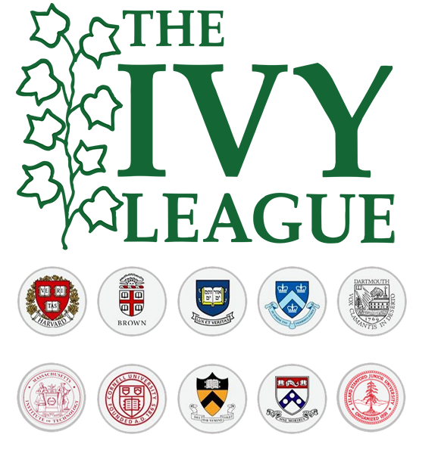

3) Read the joke below and tell what makes it so popular among the students of Ivy League?

Q: *“How many Harvard students does it take to change a lightbulb?”*

A: *“One. He holds the lightbulb still, and the whole world revolves around him.”*

After you watch.

1) What does the term “Ivy League” refer to? When was it founded?

2) Tell everything you have managed to remember about:

* Harvard University;
* Yale University;
* The University of Pennsylvania;
* Princeton University;
* Columbia University;
* Brown University;
* Dartmouth College;
* Cornell University;

Now scan the article and tell about the problems that a student can face after being enrolled into one of the Ivy League universities.

**For many poor students, the Ivy League is culture shock**

Their joyous YouTube videos go viral: poor kids getting accepted into Ivy League colleges. We see them crying, dancing, screaming, and we assume these young people have won “a golden ticket,” as sociologist Anthony Abraham Jack puts it.

But the reality for these high achievers is often something quite different. For a kid from a disadvantaged home or community, landing at an exclusive college can be dislocating, oppressive, even suffocating. In his book, “The Privileged Poor,” Jack reveals how top colleges often fail these heavily recruited students once they’re on campus.

The universities compete for low-income kids, students of color and first-generation students. “But then, once the students are there,” Jack writes, the colleges “maintain policies that not only remind those students of their disadvantage, but even serve to highlight it.”

In many respects, the institutions reflect the wealth inequality that spans the nation and demonstrate an inability to properly address it. The kids may be top students, but the culture of money and luxury brands that infests the campuses leaves them feeling like lower-class outcasts rather than full members of the community. “Money,” writes Jack, “remains a requirement for full citizenship in college, despite institutional declarations to the contrary.”

Jack conducted more than 250 hours of interviews over two years with 103 students at an elite college in the northeastern United States, which he does not identify but refers to as “Renowned University.” He bases his research on this one institution, he said, because “the conditions I have identified are common to selective colleges across the country.” He contends that his anonymous approach allowed him freer access to students and institutional research. His interviews turn up rich detail and troubling insights. What Jack discovered challenges us to think carefully about the campus lives of poor students and the responsibility elite institutions have for not only their education but also their social and economic mobility.

The students confront subtle and blatant eye-openers. Here are kids who have faced multiple evictions and homelessness mingling with the children of one-percenters who sport $895 Burberry raincoats and Longchamp bags, and who call in interior decorators to do a dorm room makeover when the existing decor doesn’t pass muster. “In another dorm across campus,” Jack writes, “a student offers one of her roommates $500 to let her have the single room of the two-room triple so that she does not have to share.”

Jack, who was once a Head Start kid in the distressed Miami community of Coconut Grove and is now an assistant professor at the Harvard Graduate School of Education, offers a key distinction in assessing the experiences of poor kids on elite campuses. Not all lower-income students are the same, he points out. Their different experiences preparing for college influence their success once they arrive. Jack distinguishes between what he calls the Privileged Poor, those who went to prep schools before college, and the Doubly Disadvantaged, those who have not.

“The Privileged Poor know a hybrid reality,” Jack writes. “They know the dangers of distressed communities and worry about the people they love who still call those places home. They also know the joys of burying their feet deep in foreign sands while studying a second language, and they know which fork to use when being served a multicourse dinner at the Biltmore or the home of an alumnus. But this new knowledge doesn’t replace the old; it sits alongside it.”

By contrast, Doubly Disadvantaged students have a steeper climb in college. “These students experience a huge jump . . . in everything from social expectations to cultural norms,” Jack explains. “In college, the people and customs are different. So are the rules that dominate social and academic life. The Doubly Disadvantaged come to see college not as a land of unbridled opportunity, but rather as one littered with new lessons of social and economic constraint and new reminders of the vast gulf between the world they came from and this new world that they don’t fully belong to.”

The interviews reveal the students’ heartbreaking vulnerability. One student eagerly accepts a cast-off velvet Ralph Lauren bathrobe from his wealthy roommate. For a moment, he considers that the rich kid’s private parts “were all over the thing but I was like, ‘It’s Ralph Lauren.’ I didn’t know Ralph Lauren was good, but I knew it was fancy. It felt hella good.”

The low-income students often can’t escape reminders of their inferior status. Because they need the money, the poor kids grab higher-paying student jobs cleaning dorm bathrooms. The students report “having to pick up soiled tampons and used condoms, mop sticky floors, sweep up dead cockroaches and rats, scoop vomit from sinks, and pull out hair stuck in clogged drains.

But the experience profoundly highlights the gap between the haves and have-nots. One student who did dorm cleaning duties saw her experience through the eyes of the rich kids. “It’s like having a maid, a student maid!” she said. “The ones who don’t have to work can just chill and be here. I have to do this. . . . To have to get on your hands and knees and scrub their toilets, it says a lot about the divides here between who has to work and who doesn’t. To be like, ‘I have to clean your sh-- because I can’t afford to go to school.’ ”

“The Privileged Poor” breaks new ground on social and educational questions of great import. Jack believes that some progress has been made in improving the plight of lower-income students — but that much more needs to be done. For one, ensuring that students have access to enough food at all times of the year is essential. “All poor students, for example,” Jack writes, “must scrounge for food in a land of plenty when cafeterias are closed during spring break.”

<https://www.washingtonpost.com/outlook/for-many-poor-students-the-ivy-league-is-culture-shock/2019/03/01/fd63ae78-2e27-11e9-813a-0ab2f17e305b_story.html>

**Video 4**  *(Ivy League – WSJ)* *(Wall Street Journal)* (<https://youtu.be/667pfuQ9lvc>)

Before you watch.

1) Do you share the view that your successful future career directly depends on the choice of the university to enter for higher education? (Why?)

2) Scan a paragraph from the article called: “Five myths about the Ivy League” from the Washington Post. And say, if Ivy League graduates dominate leadership positions in America.

Ivy League alumni conspicuously crowd some of our country’s most prominent institutions: Seven of the nine members of the Supreme Court were undergraduates at Ivy League colleges, and all nine of them attended either Harvard or Yale for law school. Every president after Ronald Reagan has had a degree from the Ivy League, often multiple. “The world that produced John Kerry and George Bush is indeed giving us our next generation of leaders,” observed William Deresiewicz in an essay for the American Scholar.

A number of studies have shown that Ivy League graduates are vastly overrepresented in positions of corporate and political leadership: Almost a third of officers and directors in the corporate elite earned undergraduate degrees from elite schools.

But overrepresentation is far from dominance. In a comprehensive 2017 study of “3,990 senior executives drawn from 15 sectors, including government,” researchers at the University of California at Riverside found that barely 10 percent attended Ivy League colleges. Ivy League graduates were most represented in industries involving media, including publishing, journalism and the arts — but even there, they were a decided minority.

Attending an Ivy League college is far from a prerequisite for leadership in America’s major institutions. In this regard, the United States is far more open and democratic than Britain, where Oxford and Cambridge graduates occupy positions in the elite to a degree unlike anything in this country: Three-quarters of Britain’s prime ministers, and the majority of its judges, journalists and civil servants, attended Oxford or Cambridge.

https://www.washingtonpost.com/outlook/five-myths/five-myths-about-the-ivy-league/2019/03/22/13fdb0da-4bf0-11e9-93d0-64dbcf38ba41_story.html

3) Study the cartoons and make your comments on them.

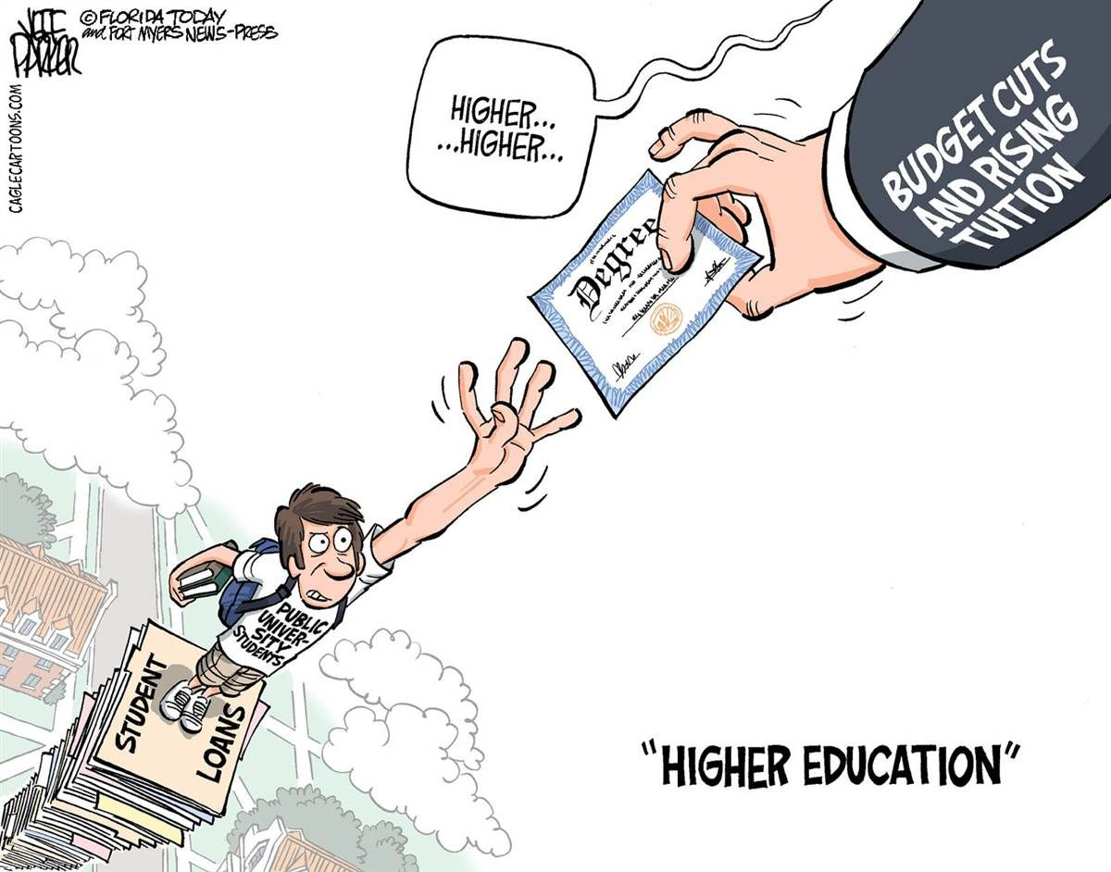

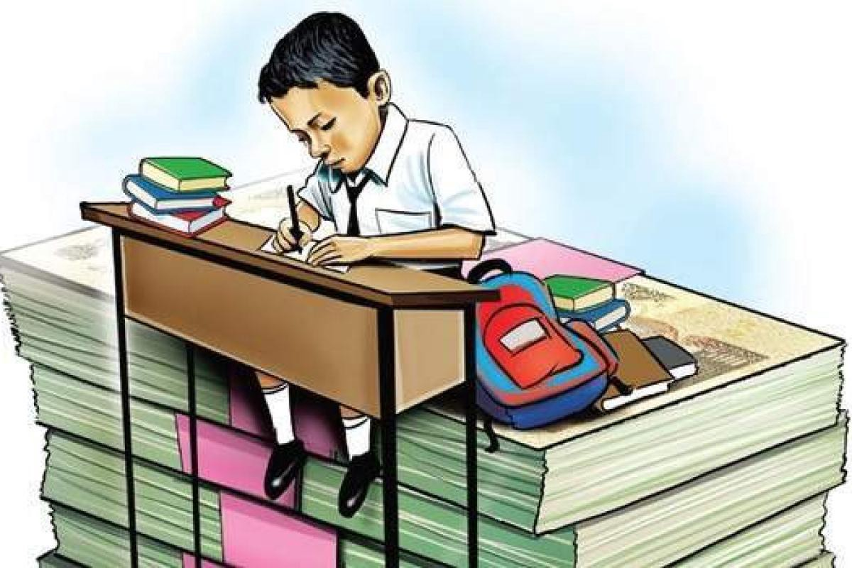

After you watch.

1) What can have a major influence on your initial and future success according to many Millennials?

2) What criteria were taken into consideration to make up the Wall Street Journal Times higher education college ranking of the top schools?

3) Which universities made the top ten according to the rating?

4) Which non-Ivy League institution was ranked highest overall?

Now scan the article and tell your own opinion about the key factors that can guarantee your future successful career.

**Why university isn't the only route to a successful career**

*A degree is all well and good but there are other ways of building a career and making a name for yourself, argues Phil Edelston*

Apart from lots of zeros on the end of their bank balance, Lord Sugar, Sir Richard Branson and Simon Cowell all have something in common: not one of them went to university, yet they have all gone on to be incredibly successful people who would probably tell you that university is not the be all and end all.

I recently saw the City & Guilds vocational rich list, which shows that the UK's top 100 "skillionaires" (people with vocational backgrounds rather than a degree) are now worth £17.6bn. This is proof that you don't have to go to university if you want to earn lots of money.

University can be a fantastic experience but having a degree is no longer a guarantee of securing a highly-paid job. With 83 graduates applying for every graduate job competition is fierce, and with increasing tuition fees and the average student debt upon leaving university currently at £25,000, I don't blame young people for reconsidering their plans to study for a degree.

For many sectors, such as law and medicine, having a university degree is a prerequisite, but there are plenty of other options. University isn't for everyone, and with competition for places so high, don't feel that it's the only option. As a business owner, I can tell you that someone who has worked in a job for three years and can demonstrate real skills while offering potential is much more employable than someone with an unrelated degree.

You also need to think about the value of your degree. Maths is relatively safe – it will always be relevant. But if you want to pursue a career in areas such as digital marketing and social media, which are developing all the time, learning in the real world will be far more beneficial.

If you think that university is not for you, or believe the barriers are insurmountable, there are alternatives and big businesses are starting to recruit more and more people at 18. For example, KPMG announced in January that it has teamed up with Durham University to offer a six-year programme for school leavers with a £20,000 starting salary, to help more people join the accountancy sector.

It's not just a select few who make it without a degree: a client I worked with recently, Andrew Morgan, is a real life example. After leaving school in 1988 with a few GCSEs, he had an initial spell as a chef and then decided to join the civil service, which he soon realised was not the path for him.

After moving to London in 1994 he had a number of sales jobs which led to him working for a training consultancy, where he experienced the world of creative marketing services and realised that's what he wanted to do as a career. With sheer determination, he pursued his dream and is now marketing and new business director for the media planning and buying agency, Arena Media. Does he think not going to university held him back? No. In fact he has many friends with MBAs and great academic successes who can't get a job because they have no work experience.

If you're not sure about university, look at what job opportunities are out there at the moment. It can be tough to get that first foot in the door, but persistence pays off. Write to companies to demonstrate your initiative, expertise and skills and ask for work experience that could really launch your career. Talk to recruitment consultants, local job centres and youth advisory centres for advice and plug into your network of friends and family. That friend of a friend could be the perfect person to help you find a position, so ask around. Building a professional network through tools like LinkedIn and Twitter will also help you connect and build relationships with the right people.

That's not to say there aren't advantages in going to university which, many argue, justify the expense. It's an investment in your future: research shows that university graduates can potentially earn £100,000 more in their lifetime on average, than non-graduates. And with so many graduates on the market, many people feel they need a degree just to keep up and not get left behind.

For many, university is about more than just a degree. It is the opportunity to learn to live by yourself, develop as a person and have the opportunity to learn more about a subject you enjoy and have a lot of fun. Rather than knowing what you want to do before you go to university, university shapes you, gives you some life experience and forms your opinion of what you want to do for a job.

So if you're planning on going to university – good luck! But if you're not, don't panic. The world, as they say, is your oyster.

What do you think? Let us know your thoughts on going to university vs starting a career straight from school in the comments section below.

https://www.theguardian.com/careers/careers-blog/university-not-only-route-successful-career

**Video 5** *(College admissions scam: How the privileged gamed the system)* *(USA TODAY)* (<https://youtu.be/761_NYlT0yQ>)

Before you watch.

1) Have you heard anything about the USA college admission scandal? If not, study the photos and headlines to get the crux of the matter.



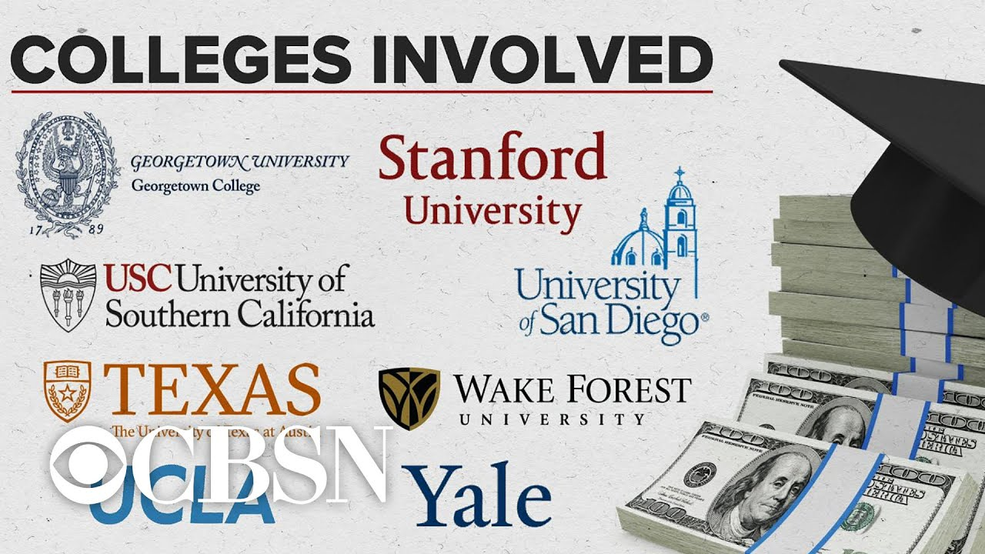2) What do you think might have happened?

After you watch.

1) What is the usual way of being admitted to college?

2) What are the loopholes in the admission system of elite colleges that were used by rich parents for their kids?

3) What students were really affected by the scheme?

Now read the article below to have a full picture of the admissions bribery scandal. Be ready to sum up the information both from the article and the video, you’ve watched.

**2019 college admissions bribery scandal**

In 2019, a scandal arose over a criminal conspiracy to influence undergraduate admissions decisions at several top American universities. The investigation into the conspiracy was code named Operation Varsity Blues. The investigation and related charges were made public on March 12, 2019, by United States federal prosecutors. At least 53 people have been charged as part of the conspiracy, a number of whom pleaded guilty or agreed to plead guilty. Thirty-three parents of college applicants are accused of paying more than $25 million between 2011 and 2018 to William Rick Singer, organizer of the scheme, who used part of the money to fraudulently inflate entrance exam test scores and bribe college officials.

Singer controlled the two firms involved in the scheme to facilitate college admission for children in more than 750 families. Singer faces up to 65 years in prison, and a fine of $1.25 million.

*Methods of fraudulent admission*

Singer primarily used two fraudulent techniques to help clients' children gain admission to elite universities: cheating on college entrance exams and fabrication of elite sports credentials.

*Cheating on college entrance exams*

Singer arranged to allow clients' children to cheat on the SAT or ACT college admission tests. Singer worked with psychologists to complete the detailed paperwork required to falsely certify clients' children as having a learning disability; this in turn gave them access to accommodations, such as extra time, while taking the tests. Singer said he could obtain a falsified disability report from a psychologist for $4,000 to $5,000, and that the report could be re-used to fraudulently obtain similar benefits at the schools.

Once the paperwork was complete, Singer told clients to invent false travel plans to arrange to have their children's test locations moved to a test center under his control, either in West Hollywood or Houston. Parents might also be advised to fabricate a family event that could provide a pretense for the student to take the SAT, ACT, or other test at a private location where Singer could have complete control over the testing process.

*Fabrication of sports credentials*

Singer also bribed college athletics staff and coaches. At certain colleges, these personnel can submit a certain number of sports recruit names to the admissions office, which then views those applications more favorably. Singer used his Key Worldwide Foundation as a money-laundering operation to pay coaches a bribe for labeling applicants as athletic recruits. He also fabricated profiles highlighting each applicant's purported athletic prowess. In some cases, image editing software (e.g., Photoshop) was used to insert a photograph of a student's face onto a photograph of another person participating in the sport to document purported athletic activity.

*Involved parties and organizations*

A total of 50 people have been charged in the investigations. This number includes 33 parents of college applicants and 11 named collegiate coaches or athletic administrators from eight universities. Three additional universities are involved, but no staff members from those schools have been directly named or implicated, believed to be Stanford, Harvard, and Northwestern.

Compiled in an abridged form from: https://en.wikipedia.org/wiki/2019_college_admissions_bribery_scandal

**Video 6** *(RUSSIAN and AMERICAN SCHOOLS: difference in education systems)* *(*[*Skyteach: открытое сообщество учителей Skyeng*](https://www.youtube.com/c/FriendlyEnglishSkyeng)*)* (<https://youtu.be/obUmsZvJJO8>) (0:00 – 9:54*)*

Before you watch.

1) What are the main differences between Russian and American schools? (Give real examples from books and movies to support your ideas).

2) Does the attitude towards schools in Russia differ from that in the USA? (What are the main values, what are the relations between the classmates, between parents and teachers? In what way has the attitude towards the learning process and school rules changed from the time of the USSR?)

3) Now watch the pre-video ( 2+2=22) and make your own assumptions: <https://youtu.be/Z3IZxHFGFGI>

4) Study the cartoons below and say what problems are highlighted.

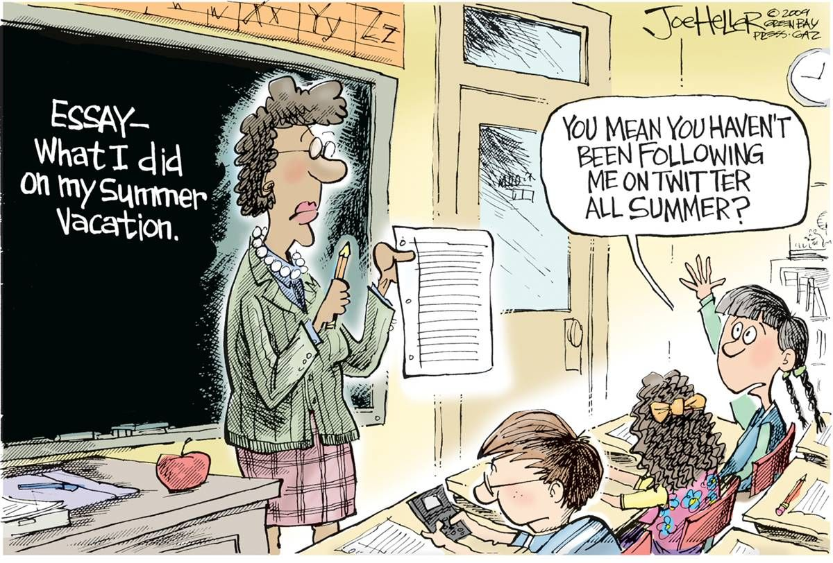

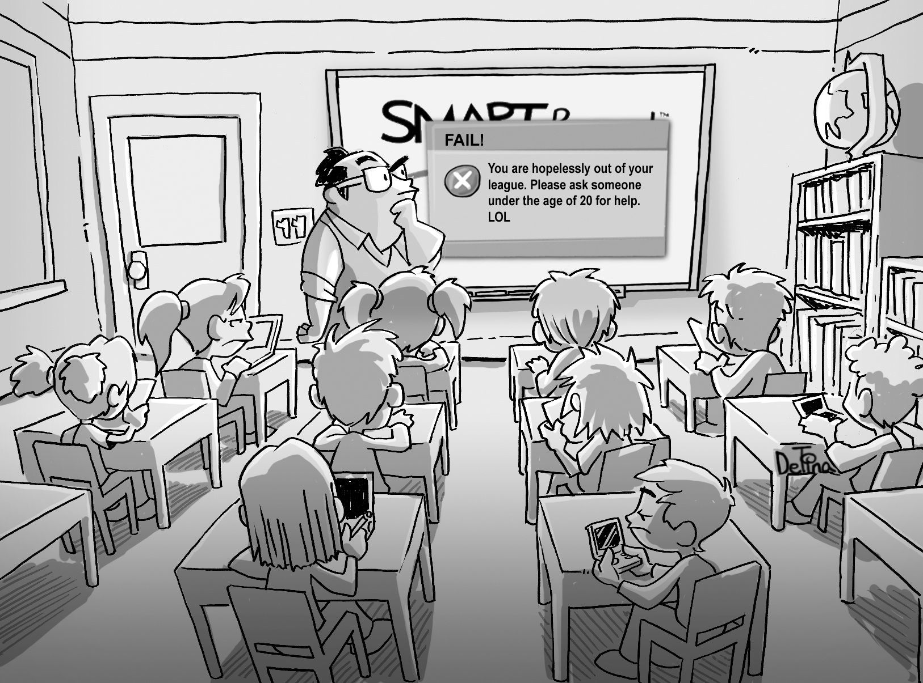

After you watch.

1) What are the main differences in the types of schools in Russia and in the USA?

2) What is the main difference of Russian and American teaching process in middle school?

3) What are the ways to assess the results of students’ studies according to both systems?

4) What kind of diaries are used in both systems?

5) Can you agree with the statement that: “…there is a more competitive spirit in Russia…”?

6) Speak on the events that are usually organized during a school year in both countries.

7) What is “homecoming”?

8) Tell about some differences in school schedules in Russia and in the USA. What are the cases when schools can be cancelled?

9) Do the options after high school in the USA differ from those in Russia?

Now read the article about most acute problems that the US schools are facing now and be ready to discuss them comparing with the situation in Russian schools.

**The 15 Biggest Failures of the American Public Education System**

The world is in a constant state of change and those who fail to adjust fall behind. Unfortunately, the American public education system has not kept up with the times and is currently facing a number of serious problems. Keep reading to learn about the biggest failures affecting the modern U.S. public education system as well as some of the trends that could spark change.

Here are the top 15 failures affecting the American public education system:

1. Deficits in government funding for schools.

Funding is always an issue for schools and is, in fact, one of the biggest issues facing the American public education system today. For more than 90% of K-12 schools, funding comes from state and local governments, largely generated by sales and income taxes. Research shows, however, that funding has not increased with need – many states are still issuing funding that is lower than it was before the Great Recession. Lower funding means fewer teachers, fewer programs, and diminished resources.

2. Decline in school safety.

There has been a string of high-profile mass shootings in American schools, resulting not only in dozens of deaths but many debates about school safety. In one poll, over 50% of teenagers said they were worried about the possibility of gun violence in school. Teachers all across the country are faced with the problem of figuring out how to prevent attacks and protect the lives of students and personnel. Some suggest special straining for teachers and concealed weapons might make schools safer while critics argue that more guns in schools could lead to more accidents and injuries.

3. Challenges with technology in education.

Today’s students have grown up using technology and have come to expect it in the classroom, but there are arguments about how large a role technology should play in education. Supporters suggest that technology creates the potential for more active student engagement and provides instant access to up-to-date resources while critics say it could be a distraction. While technology in the class room certainly has its benefits, certain aspects of technology are challenging. For example, smartphones and easy access to technology have made it easier for students to cheat and can negatively impact learning.

4. Controversy over charter schools and voucher programs.

Another hot topic in education today is school choice. Charter schools and school vouchers allow parents to choose options other than traditional public schools for their children. Charter schools are funded by a combination of private and public funds and operate outside the public-school system. School vouchers allow parents to use public funds to send their child to a school of choice, including private schools. Critics of these schools suggest that charter schools and voucher programs siphon funds away from public schools that are already struggling financially.

5. Problems with common core curriculum.

The Common Core State Standards were developed to specify exactly what students should know before graduating high school. It was developed in 2009 to promote educational equity across the country, holding all students to the same standardized testing requirements. Some see the problem as federal intrusion into the state control of education and others say that it doesn’t allow for teacher innovation and flexibility with the learning process. Most states adopted the standards when they were introduced but more than a dozen have since repealed or revised them.

6. Decreased teacher salaries.

Teacher salaries are by no means impressive and, in most states, they have decreased steadily over the past few years. In fact, research shows that the average salary for public elementary and secondary school teachers dropped by nearly 5% between the 2009/10 school year and now. States like Oklahoma and Colorado experienced a 17% and 16% decrease – these states also saw massive teacher walkouts in 2018. There are, of course, some states where teacher salaries increased, and some teachers received a growth in benefits that may or may not be enough to balanced out wages that are low overall.

7. Emphasis on standardized testing.

Along with Common Core, there has been an increased focus on standardized testing, especially during the No Child Left Behind years. Schools and teachers are judged based on student test scores which, many argue, is not a fair or accurate measure of efficacy. Many critics argue that standardized testing is one of the biggest problems in American education, suggesting that the pressure to produce high test scores leads to a teach-to-the-test approach and reduced focus on non-tested subjects like art.

8. Arguments about teacher tenure.

Tenure is designed to protect teachers from being fired for personal or political reasons – the school district must demonstrate just cause. In many states, tenure is granted to public school teachers who have consistently received satisfactory evaluations, though some states don’t award it at all. Supporters suggest that tenured teachers can advocate for students without having fears of reprisal while critics say that it makes it harder for school districts to dismiss ineffectual teachers. Some also suggest that tenure may encourage complacency, allowing teachers to put forth minimal effort.

9. Bullying in schools.

Violence in schools is a rising issue and bullying is a key contributor. According to the National Center for Education Statistics, over 20% of students in grades 6 through 12 have been bullied either in school or on their way to/from school. This figure is actually down from 32% in 2007 but is still much too high. The challenge with these statistics is that many students who are bullied do NOT report it. Bullied students experience a wide range of physical, behavioral, and emotional problems that can impact not only their education but also their lives.

10. Growing problems with student poverty.

According to data from the National Center for Education Statistics, more than 50% of the public-school population in the United States was made up of low-income students. This is a significant increase from 38% in 2001. This is a nationwide problem with 40% of public-school students qualifying for free or reduced-price lunches in 40 states. In 18 of those states, student poverty rates were over 50%. Studies have shown that low-income students tend to perform lower than affluent students and family income shows strong correlation with student achievement measured by standardized tests.

11. Schools are overcrowded.

In the 2011/12 school year, the average class size in American public schools was about 21 students in elementary school and almost 27 students in secondary school. Anecdotal reports, however, suggest that classrooms today have closer to 30, and in some cases, 40 students. Teachers and other proponents of smaller class sizes suggest that class size influences the quality of instruction with smaller class sizes having improved student outcomes. Critics say that the cost of limiting class sizes is a limiting factor and that it may not be worth it. In Florida, class sizes were capped in 2002 but a 2010 study showed no significant impact in test scores for students in grades 4 through 8.

12. Student mental health challenges.

Mental health is a growing concern in the United States and one that even affects school students. A 2018 study showed that nearly two-thirds of college students experienced overwhelming anxiety and anxiety has been reported in younger students as well. Even schools that are trying to make a difference face challenges. For example, the recommended ratio of students to counsellors is one counselor for every 1,000 to 1,500 students but the U.S. college campus average is 1,737 to 1. Awareness of mental health issues is increasing, but there is still a stigma that prevents many students from seeking care.

13. Parents are not involved enough.

Teachers in public schools can only do so much to support their students. When the students go home for the day, the state of their home life can impact their development both personally and academically. In cases where parents lack higher education, they may not be able to provide the assistance students need to learn and to complete homework. Students in low-income families face additional challenges at home, though even middle- and upper-class families aren’t off the hook. In many families, parents are too career-focused and have little time to spend supporting their child’s education.

14. Too many schools are being closed.

Schools all over the country are closing their doors in numbers that are quite alarming. This only leads to an increase in issues with large class sizes and poor access to resources. It is easy for parents, teachers, and communities that are affected by closures to feel targeted even when school board members provide unbiased data. In some cases, closures cannot be prevented but they can be delayed and communities should consider other solutions or alternative uses for the school such as a community center or adult education center.

15. Lack of teacher innovation and outdated teaching methods.

The teaching methods used decades ago simply do not work for the modern student. One of the biggest things holding back the American public education system is a lack of teacher innovation, partially created by enforcement of standardized testing and Common Core curriculum. Unfortunately, the problem really needs to be addressed at the federal level with changes to policies that will result in change within the public education system. America needs teachers who are better trained to meet the needs of their students and who are willing to speak up and facilitate change. Teachers are on the front lines and, without them speaking up, change is not possible.

<https://www.publicschoolreview.com/blog/the-15-biggest-failures-of-the-american-public-education-system>

**Video 7** (*Advantages and Disadvantages of Online Learning) (Pat Belgrave)* (<https://youtu.be/XZsvsZ0Au4A>) (0:00- 3:21)

Before you watch.

The COVID-19 pandemic changed learning in many unprecedented ways. Students had to not just move to online learning but also keep a social distance from their friends and family. It was quite challenging for some to adjust to the ‘new normal’ and missed the in-person interaction with their teachers.

1) How do you feel overall about distance education? What are your thoughts on the growing popularity of online learning? Do you think there is an increasing trend? Is it a good or bad idea to take an online program?

2) s it a problem nowadays to have uninterrupted access to a device while learning online? Have you ever faced any challenges with the device’s hardware quality? Have you ever had a problem to share the device with others in the house?

3) What device do you use for distance learning? (laptop, desktop, smartphone, or tablet) which one from your point of view can be an ideal choice for its screen size and quality?

4) How much time do you think it’s ok to spend each day on an average on distance education?

5) What is needed to make remote learning the most effective?

6) In what cases can distant learning be stressful?

7) Can any problems arise connected with bad time-management and discipline while learning remotely? What tips can you give to help solve these problems?



After you watch.

1) Enumerate all advantages and disadvantages mentioned in the video and be ready to give you comments on them.

2) Think it over, try to recall your own experience and add more advantages and disadvantages to the list.

Now scan the article and tell whether it has changed at least your attitude towards online learning.

**Failing grades spike in Virginia’s largest school system as online learning gap emerges nationwide**

A report on student grades from one of the nation’s largest school districts offers some of the first concrete evidence that online learning is forcing a striking drop in students’ academic performance, and that the most vulnerable students — children with disabilities and English-language learners — are suffering the most.

Fairfax County Public Schools in Virginia, which has been mostly online since March, [published an internal analysis this week](https://go.boarddocs.com/vsba/fairfax/Board.nsf/files/BVJV847F7247/$file/Q1%20Marks%20Rpt%20-%20v6%20lzh.pdf) showing that, between the last academic year and this one, the percentage of middle school and high school students earning F’s in at least two classes jumped by 83 percent: from 6 percent to 11 percent. By the end of the first quarter of 2020-2021, nearly 10,000 Fairfax students had scored F’s in two or more classes — an increase of more than 4,300 students as compared with the group who received F’s by the same time last year.

Experts have warned since the beginning of the pandemic, and the unexpected national experiment in online learning, that remote schooling would take a serious academic toll on children.

Now, evidence of poor achievement in virtual classrooms is beginning to emerge nationwide: In the Independent School District in Houston, [more than 40 percent of students are earning failing grades](https://www.houstonchronicle.com/news/houston-texas/education/article/houston-schools-fail-grades-surge-class-15743142.php?utm_campaign=CMS%20Sharing%20Tools%20(Premium)&utm_source=t.co&utm_medium=referral) in at least two of their classes, according to data reported by the Houston Chronicle. Likewise in St. Paul, Minn., where the superintendent recently reported that [nearly 40 percent of St. Paul Public Schools high-schoolers](https://www.kare11.com/article/news/education/nearing-end-of-1st-quarter-nearly-40-of-st-paul-public-high-school-students-have-failing-grades/89-d3da0082-10e5-4673-b96c-9502a9044b9b) have failing marks, local TV station KARE reported.

Educators have struggled with the question of how to grade students in a virtual environment since the spring. Many districts opted for a pass/fail system to close out the final quarter of the 2019-2020 school year because students and teachers had been thrust into an online-only world with almost no time to adjust or prepare.

But the tactic led to significant dips in engagement and attendance, as families forced to navigate the vagaries of the pandemic prioritized other concerns. So, after school districts built remote learning curriculums from scratch over the summer, many advised teachers they should grade as close as possible to what they normally would come fall. School officials hoped to send a message: Students must take virtual school seriously.

The apparent consequences of that decision, demonstrated afresh by the Fairfax statistics published this week, are confirming fears about how the pandemic is driving an equity gap in American education that may prove impossible to close. Fairfax’s data shows that children who are engaged and care deeply about school — children in stable home situations, whose parents have sufficient resources — will stay engaged in an online environment, while children whose temperament, socioeconomic status or home situation have historically barred them from academic achievement will slip further and further behind.

Children who were middling or poor students suddenly began earning more failing marks, including in classes they had not failed before, according to the Fairfax analysis. Historically low-performing students are seeing an explosion of C’s, D’s and F’s this semester, far more than would have been expected based on their pattern of achievement in past years.

“Results indicate a widening gap between students who were previously performing satisfactorily and those performing unsatisfactorily,” the report concludes. “Students who performed well previously primarily performed slightly better than expected during Q1 of this year.”

“In contrast, students who were previously not performing well, performed considerably less well,” it continues.

Even in normal times, factors such as socioeconomic status, race and whether parents speak English accounted for roughly two-thirds of student achievement scores and standardized test prowess, said Jack Schneider, an assistant professor of education at the University of Massachusetts at Lowell who directs research for the Massachusetts Consortium for Innovative Education and recently [published a book on](https://www.amazon.com/Beyond-Test-Scores-Measure-Quality/dp/0674976398/ref=sr_1_1?ie=UTF8&qid=1493860066&sr=8-1&keywords=beyond+test+scores) public-school testing.

At this phase of the pandemic, he said, the United States has reached a tipping point: The damage done to schoolchildren with scarce resources is likely to be irreparable. The best thing the nation can do would be to offer everyone a “do-over,” Schneider said.

“The default should be, once we’re in-person again, everybody could go back to the grade they were in March of 2020,” he said. “We need to slow the pace down in the name of equity.”

Again, the dip is especially severe among vulnerable children and those for whom English is not their first language. Students with disabilities and Hispanic students both saw large spikes in underperformance, compared with other demographic groups studied.

But by far the biggest drop came for learners whose primary language is not English: Forty-seven percent are underperforming in math this year, while 53 percent are underperforming in English.

Fairfax mother Rocio Portillo, 35, said she was saddened but not surprised by the report. That’s because of what happened this semester to her daughter, a 17-year-old high school junior.

The teen achieved mostly A’s and B’s pre-pandemic. She was on track to fulfill her dream of studying forensic psychology in a four-year college. That wish is shared by her mother, who never finished college.

Then online learning hit. The teen cried every day during the first week this semester because she finds Zoom school nearly impossible to follow: The format is confusing and some teachers talk too fast. Despite hours of studying every day, her grades have slipped to C’s and one F.

Recently, Portillo sat down with her daughter to suggest attending community college.

“What breaks me is that I know she’s trying, I know she is giving it her all,” Portillo said. “She knows that college is important. She wants to be somebody in life.”

Compiled in an abridged form from:

<https://www.washingtonpost.com/local/education/fairfax-schools-more-failing-grades/2020/11/24/1ac2412e-2e34-11eb-96c2-aac3f162215d_story.html>

**RELIGION**

**Video 1** *(The five major world religions - John Bellaimey) (TEDEd)*

Before you watch.

1. What is religion? What does it matter to you?
2. What are the major religions in the world? Where are they practised? The image below can give you a hint.

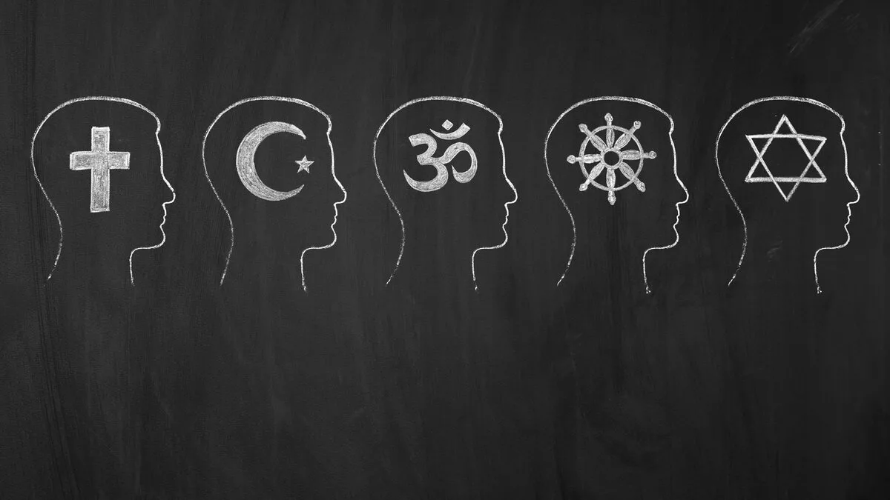

1. Have you ever come across the concepts: Krishna, samsara, Canaan, Moses, The Talmud, Siddhartha, the Eightfold Path, the Ten Commandments, Gabriel, Muhammad, the Five Pillars? What do they mean or refer to?

Watch the video to find out whether you are right.

After you watch.

1. Which religion is the most ancient? How old is it?
2. Where is Hinduism practised? How many Hindus are there?
3. What does Hinduism teach? Why is it vital for a Hindu to follow their dharma?
4. What is samsara? Is it possible to escape it?
5. Is Hinduism a monotheistic religion?
6. Why did Judaism stand out from other beliefs and faiths of that time?
7. When and what did Judaism begin with?
8. Why is Judaism called a religion of the book? What are the Jews’ holy books?
9. Did the transformation from a temple religion into a religion of the book impact on the faith itself?
10. How many Jews are there in the world?
11. What religion did Buddhism grow out of?
12. Who was prince Siddhartha? Why is he strongly associated with Buddhism?
13. What did Siddhartha try to investigate? With what means?
14. What wisdom helped him to find his way? How did that transform the prince himself?
15. What is the Eightfold Path?
16. Where is Buddhism practised? How many followers does it have?
17. Why are Christianity and Judaism interlinked?
18. What did Jesus preach? Why would he invite everyone to a common table?
19. What has been the message of Christianity?
20. What Christian celebrations are mentioned in the video? What do they symbolize?
21. How big is the Christian Church’s congregation?
22. When and what did Islam begin with?
23. What does a ‘Muslim’ mean?
24. What are the five most important duties of a true Muslim?
25. Do Muslims have a holy book?
26. How many people embrace Islam?
27. What is common to all religions?

Follow-up activity.

Draw a mind map on the major world religions making use of the information in the video.

**Video 2** *(Why There is No Way Back for Religion in the West) (TEDxUnivercityofEssex)*

Before you watch.

1. To your thinking, what role does religion play in modern Western society? How can you account for that state of affairs?
2. In your opinion, is religion losing ground in other parts of the globe? Why / why not?

After you watch.

1. What phenomenon has the greatest effect on religion in the West, according to the lecturer? Are there any exceptions?
2. What factors might connect modernization with problems for religion?
3. What is the secular transition? How does the lecturer prove that this process is underway?
4. Are there any objections to the secularisation trend? Does Mr Voas dismiss or accept them?
5. Is it possible for religion to bounce back in the Western countries? Why / why not?
6. Do you find the lecturer’s theses convincing? Give your reason.

Scan the article for statistics and data and say whether the figures prove the current trend in religious decline. Are you surprised at any fact?

**'Christianity as default is gone': the rise of a non-Christian Europe**

Figures show a majority of young adults in 12 countries have no faith, with Czechs least religious

[*Harriet Sherwood*](https://www.theguardian.com/profile/harrietsherwood)*, The Guardian, 21 Mar 2018*

Europe’s march towards a post-Christian society has been starkly illustrated by research showing a majority of young people in a dozen countries do not follow a religion.

The survey of 16- to 29-year-olds found the Czech Republic is the least religious country in [Europe](https://www.theguardian.com/world/europe-news), with 91% of that age group saying they have no religious affiliation. Between 70% and 80% of young adults in Estonia, Sweden and the Netherlands also categorise themselves as non-religious.

The most religious country is Poland, where 17% of young adults define themselves as non-religious, followed by Lithuania with 25%.

In the UK, only 7% of young adults identify as Anglican, fewer than the 10% who categorise themselves as Catholic. Young Muslims, at 6%, are on the brink of overtaking those who consider themselves [part of the country’s established church](https://www.theguardian.com/world/2017/may/13/uk-losing-faith-religion-young-reject-parents-beliefs).

The figures are published in a report, Europe’s Young Adults and [Religion](https://www.theguardian.com/world/religion), by Stephen Bullivant, a professor of theology and the sociology of religion at St Mary’s University in London. They are based on data from the European social survey 2014-16.

Religion was “moribund”, he said. “With some notable exceptions, young adults increasingly are not identifying with or practising religion.”

The trajectory was likely to become more marked. “Christianity as a default, as a norm, is gone, and probably gone for good – or at least for the next 100 years,” Bullivant said.

But there were significant variations, he said. “Countries that are next door to one another, with similar cultural backgrounds and histories, have wildly different religious profiles.”

The two most religious countries, Poland and Lithuania, and the two least religious, the Czech Republic and Estonia, are post-communist states.

The trend of religious affiliation was repeated when young people were asked about religious practice. Only in Poland, Portugal and Ireland did more than 10% of young people say they attend services at least once a week.

In the Czech Republic, 70% said they never went to church or any other place of worship, and 80% said they never pray. In the UK, France, Belgium, Spain and the Netherlands, between 56% and 60% said they never go to church, and between 63% and 66% said they never pray.

Among those identifying as Catholic, there was wide variation in levels of commitment. More than 80% of young Poles say they are Catholic, with about half going to mass at least once a week. In Lithuania, where 70% of young adults say they are Catholic, only 5% go to mass weekly.

According to Bullivant, many young Europeans “will have been baptised and then never darken the door of a church again. Cultural religious identities just aren’t being passed on from parents to children. It just washes straight off them.”

The figures for the UK were partly explained by high immigration, he added. “One in five Catholics in the UK were not born in the UK.

“And we know the Muslim birthrate is higher than the general population, and they have much higher [religious] retention rates.”

In Ireland, there has been a significant decline in religiosity over the past 30 years, “but compared to anywhere else in western Europe, it still looks pretty religious”, Bullivant said.

“The new default setting is ‘no religion’, and the few who are religious see themselves as swimming against the tide,” he said.

“In 20- or 30-years’ time, mainstream churches will be smaller, but the few people left will be highly committed.”

Follow-up activity.

Conduct research on religiosity in the Russian Federation. The questions below may be of use.

1. Is religion in decline or on the rise? Does religious affiliation differ from region to region? How can you explain that?
2. Do the Russian data correspond with Mr Voas’s thesis? Why / why not?

**Video 3***(Is religion dying out in Britain?)* *(*[*Humanists UK*](https://www.youtube.com/channel/UCFHH0VMmsXEUzBzbClMkb0g)*)*

Before you watch.

1. Do you have any background knowledge about the following: The Church of England, Pentecostalism, the Methodist Church, Hinduism (ISKCON and Swaminarayan)?
2. You are going to watch a video about religion in Great Britain. Try to guess who is participating in the show; what issues may be under discussion; what answer to the main question the participants are likely to give.

Watch the video to find out whether your guesses turn out to be accurate.

After you watch.

1. What does the recent survey indicate for the first time? To your thinking, is this finding significant to modern Britain? Give your reasons.
2. A number of causes of significant changes in religious affiliation in the UK are provided in the video. What are they? Do you find the explanations reasonable?
3. Is the declining trend spreading throughout all Christian denominations in Great Britain? Why / why not?
4. What is the situation like within Islam? What contributes to that?
5. What is happening in Hinduism in Great Britain? Why?
6. Is religion dying in the UK, according to the experts at the show? Do they take a common stand on the issue?
7. Do the experts offer a solution to reverse or adapt to the current trend? Can it work out, if they do?

Scan the article for additional information on the topic. Sum the article up.

**UK secularism on rise as more than half say they have no religion**

*Harriet Sherwood, The Guardian, 12 Jul 2019*

The growth of secularism in the UK is unabated with fresh data showing stark generational differences and a new confidence among the non-religious to declare themselves atheist.

Only 1% of people aged 18-24 identify as Church of England, according to the British Social Attitudes (BSA) survey for 2018. Even among over-75s, the most religious age group, only one in three people describe themselves as C of E.

Across all age groups, the younger people are the less likely they are to call themselves Anglican.

The steady decline in religious belief among the British public is “one of the most important trends in postwar history”, says the BSA report.

Fifty-two percent of the public say they do not belong to any religion, compared with 31% in 1983 when the BSA survey began tracking religious belief. The number of people identifying as Christian has fallen from 66% to 38% over the same period.

“Britain is becoming more secular not because adults are losing their religion but because older people with an attachment to the C of E and other Christian denominations are gradually being replaced in the population by younger unaffiliated people,” says the report.

“To put it another way, religious decline in Britain is generational; people tend to be less religious than their parents, and on average their children are even less religious than they are.”

Non-religious parents successfully transmit their lack of faith to their children, but two religious parents have only a 50/50 chance of passing on their faith, the report says.

The non-religious are increasingly atheist. One in four members of the public stated: “I do not believe in God,” compared with one in 10 in 1998. The figures challenge theories that people are “believing but not belonging” – in other words, that faith has become private rather than institutional – the report says.

The proportion of people who say they are “very or extremely non-religious” has more than doubled, from 14% to 33% in the past two decades.

Nevertheless, most people are tolerant of others’ religious beliefs. A large majority of both non-believers and people of faith have positive or neutral views of individuals who belong to a religion.

Only 3% of people say they would definitely not accept a mixed-faith marriage within their family, with 82% saying they would definitely or probably accept someone from a different religion marrying a relative.

As religious adherence declines, trust in scientific institutions is increasing, says the report. University scientists have a higher trust rating (82%) than corporate scientists (67%).

In terms of confidence in institutions, 11% of people say they trust churches and religious organisations, compared with 36% who have confidence in the education system, 34% in the legal system, 16% in business and industry and 8% in parliament.

Follow-up activity.

Stage a panel discussion on the role of religion in modern society.

**Video 4** *(What Are the Most Atheist Countries?) (NowThis World)*

Before you watch.

1. Do you distinguish between an atheist and an agnostic? The cartoon below may be of use.
2. In your opinion, is the percentage of ‘nones’ of all religious groups decreasing or increasing? How can you explain the tendency?



After you watch.

1. Why is it difficult to analyze non-religiosity?
2. What is the total number of non-religious population? Where do the overwhelming majority of the unaffiliated live? Why? What about the rest of the globe?
3. What are the most atheistic countries, according to the video?
4. What are the roots of lack of religion in:

* The Czech Republic,
* Japan,
* China,
* North Korea?

1. What does a Pew forecast for the future of religion suggest? What is it based on?
2. Do you incline to agree or disagree with the Pew forecast? Give your reasons.

Follow-up activity.

Scan the article for Russian statistics. Are you taken aback by the findings of the poll? What may they suggest?

**Number of atheists in Russia halves in 3 years – poll**

*RT, 27 Jul 2017*

The number of Russians who describe themselves as atheists has fallen from 26 to 13 percent in just three years, according to recent research. The share of those who back the Church’s involvement in state politics has increased slightly.

The poll, conducted by the Russian independent research center Levada in late June, showed that majority of Russians (62 percent) describe their attitude to atheists as “good and respectful,” with only 8 percent stating negative feelings towards this group. These figures remain virtually unchanged since 2014.

At the same time, the share of those who describe themselves as atheists fell sharply over this period – from 26 percent in 2014 to 13 percent today. Nine percent of participants in the poll said that they considered themselves “very religious” and 44 percent said they were “partly religious.”

In the same poll, 28 percent of respondents said that they were confident that the Church must influence the decision-making process in the upper echelons of state power. This is up from 26 percent three years ago.

The share of those who oppose such actions remained unchanged at 36 percent, while 39 percent said that in their minds the influence of the Church on state politics was “exactly at the necessary level.”

When researchers asked the Russian public about their attitude to representatives of various popular religions and confessions, Orthodox Christianity came out as the most popular with the approval of 92 percent of respondents. Just under three-quarters (74 percent) said that they had positive feelings towards Catholics and 61 percent said they felt respect towards Protestants.

The share of those who reported positive feelings towards Muslims is now 59 percent – which is unchanged since 2013. Seventeen percent described their feelings towards Muslims as “controversial” and 13 percent as “fear and hostility.”

Just over half (55 percent) of Russians said they had a good attitude to Jewish people, with 17 reporting controversial feelings and 11 percent stating they had negative sentiments.

Analysts from the Levada Center noted in comments published on the group’s website that while the share of religious people in the country was on the increase, the strength of their faith was apparently getting weaker.

“The increase in the number of believers is not accompanied by sincere faith or understanding of importance of the religion for spiritual life,” the comments read.

“Indirectly, the weakness of Orthodox Christian norms can be confirmed by growing opposition to restrictions imposed during major fasts – such as the restrictions on entertainment, alcohol or sex. The number of people who say that they are not ready to bear this burden has increased up to two times over the past few years.”

**Video 5a** *(Islam - fastest growing religion) (EWTN, 2017-09-15)*

**Video 5b** *(The Future of World Religion (in 2050)) (TDC)*

Before you watch.

You are going to watch videos about the future of religion. Think of what predictions or projections of the issue pundits may make. To your thinking, will they be mostly positive or negative?

Watch the videos to find out whether you are right.

After you watch.

1. How is religious landscape changing in general, according to the Pew Research Center? Give some statistics.
2. What contributes to the rapid growth of Muslims? Provide some statistics.
3. What future is Christianity likely to face? What geographic and social factors will affect this religious group? Support your answer with some figures.
4. Are these projections irreversible? Why / why not?
5. What impression do these videos produce on you?

Read the article, point out the key messages, express your agreement or disagreement with them.

Do you share the author’s opinion that the future of religion is bleak? Give your reasons.

**Why the Future of Religion Is Bleak**

*Daniel C. Dennett, The Wall Street Journal, 26 April 2015*

Religion has been waning in influence for several centuries, especially in Europe and North America. There have been a few brief and local revivals, but in recent years the pace of decline has accelerated.

Today one of the largest categories of religious affiliation in the world—with more than a billion people—is no religion at all, the “Nones.” One out of six Americans is already a None; by 2050, the figure will be one out of four, according to a new Pew Research Center study. Churches are being closed by the hundreds, deconsecrated and rehabilitated as housing, offices, restaurants and the like, or just abandoned.

If this trend continues, religion largely will evaporate, at least in the West. Pockets of intense religious activity may continue, made up of people who will be more sharply differentiated from most of society in attitudes and customs, a likely source of growing tension and conflict.

Could anything turn this decline around? Yes, unfortunately. A global plague, a world war fought over water or oil, the collapse of the Internet (and thereby almost all electronic communication) or some as-yet unimagined catastrophe could throw the remaining population into misery and fear, the soil in which religion flourishes best.

**Behind the decline**

With hardly any significant exceptions, religion recedes whenever human security and well-being rises, a fact that has recently been shown in numerous studies, but was suspected by John Calvin in the 16th century. He noted that the more prosperous and comfortable his Genevans became, the less dependent they were on church. Presumably, those who deplore the decline of religion in the world today would not welcome the sort of devastation and despair that could give religion its second wind.

There is no other plausible scenario that could halt the slide, for a fairly obvious reason: the recent rapid growth of mutual knowledge, thanks to the global spread of electronic and digital communication.

Any institution—just like a person or an organism—depends on a modicum of privacy in which to conduct its business and control its activities without too much interference and too many prying eyes. Religious institutions, since their founding millennia ago, have managed to keep secrets and to control what their flocks knew about the world, about other religions and about the inner workings of their own religion with relative ease. Today it is next to impossible.

What is particularly corrosive to religion isn’t just the newly available information that can be unearthed by the curious, but the ambient knowledge that is shared by the general populace.

**Funny business**

Laughter is particularly subversive. A Mormon watching the episode of “South Park” that lampoons the Church of Latter-day Saints doesn’t just see some outsiders poking fun at her religion. She learns that vast numbers of people find her religion comical, preposterous, ludicrous, as confirmed by the writers’ decision to belittle it and the networks’ decision to broadcast it. This may heighten her loyalty, but it also may shake her confidence, and as soon as she even entertains the hypothesis that belief in God might be a life-enhancing illusion, not a rock-solid truth, she is on the slippery slope.

The late computer scientist John McCarthy, a founder of artificial intelligence, once said, “When I see a slippery slope, my instinct is to build a terrace.” That’s what theologians have been doing for hundreds of years, shoring up whatever they think they can salvage from the rain of information eroding their ancient peaks of doctrine. In some denominations the clergy are obliged to swear to uphold the “inerrant truth” of every sentence in the Bible, but this is becoming more of an embarrassment than a shield against doubt.

Hardly anybody today believes in—or would want to believe in—the wrathful, Old Testament Jehovah, for instance. A God who commands our love is a nasty piece of work by today’s perspectives, and has been replaced, over the centuries, by ever-less-anthropomorphic (but more “loving,” more “forgiving”) addressees of our prayers. (Isn’t it curious how the obsolete term “God-fearing” is still used in some quarters as a commendation?) God has no ears, but may “listen” to our prayers, and “works in mysterious ways,” which is a face-saving way of acknowledging that He doesn’t answer them at all.

Do you remember the impressive and rigorous Benson Study? It was conducted by a Harvard Medical School team that labored for years. It was finally published in 2006, and it concluded that intercessionary prayer for the recovery of heart-surgery patients not only didn’t work; in some conditions it showed a small but measurable increase in post-surgical complications.

**Media bias**

This was dutifully reported by the media, and promptly forgotten by most. But if the study had found any positive result, you can be sure it would have been on the cover of all the newsmagazines and featured in television specials. This pro-religion bias in the media is crumbling, however, and once it dissolves, the exposure of all the antique falsehoods of religious doctrine will oblige the theologians to build yet another terrace, lower down the slope. They are running out of rocks.

Religious leaders of all faiths are struggling to find ways of keeping their institutions going, and one of the themes emerging from the surveys they conduct is that creed should be de-emphasized and loyalty and community should be fostered.

If we are lucky—if human health and security continue to rise and spread around the globe—churches might evolve into humanist communities and social clubs, dedicated to good works, with distinctive ceremonies and disappearing doctrine, except for a scattering of reclusive sects marked by something like institutional paranoia.

If we are unlucky and calamity strikes, our anxiety and misery will provide plenty of fuel for revivals and inventions of religions we have happily learned to live without.